What is Sharding?
Sharding is a database partitioning technique that splits very large databases into smaller, faster, more easily managed parts called shards. Each shard contains a subset of the total data and operates independently on its own hardware. This distributes the workload across multiple database servers, improving performance and scalability.
Think of a large library with millions of books. Finding a specific book in a single massive collection can be slow and inefficient. Sharding is like dividing the library into several smaller branches, each containing a specific category or range of books. You only need to search the relevant branch to find your book quickly.
Why Use Sharding?
- Improved Performance: Querying smaller datasets is faster.
- Increased Scalability: You can add more shards as your data grows, distributing the load.
- Higher Availability: If one shard goes down, the other shards remain operational (depending on the sharding strategy and replication).
- Easier Management: Smaller databases are easier to manage, back up, and restore.
Sharding Example
Imagine you have a database storing user information for a popular social media platform. Without sharding, all user data resides on a single large database server. As the number of users grows, the database becomes slow and difficult to manage.
With sharding, you can split the user data based on a specific criteria, such as the first letter of their username.
- Shard A: Contains user data for usernames starting with A-M.
- Shard B: Contains user data for usernames starting with N-Z.
When a user tries to log in, the system determines which shard contains their data based on their username and directs the query to that specific shard. This significantly reduces the amount of data that needs to be searched, leading to faster login times.
Here's a visual representation:
Each shard would reside on its own database server. If the number of users with usernames starting with A-M grows significantly, you can further split Shard A into even smaller shards.
Key Considerations in Sharding
- Sharding Key: The column or attribute used to determine how data is distributed across shards (e.g., user ID, username, geographic region). Choosing an appropriate sharding key is crucial for even data distribution and query efficiency. Poor key selection can lead to hot spots where some shards are heavily loaded while others are underutilized.
- Sharding Strategy: Different methods for determining which shard a piece of data belongs to (e.g., range-based sharding, hash-based sharding, directory-based sharding).
- Query Routing: Determining which shard(s) to query to retrieve the requested data.
- Data Consistency: Maintaining data consistency across multiple independent shards can be challenging, especially during updates or transactions that involve data in multiple shards. Techniques like two-phase commit can be used but can add complexity.
- Rebalancing: Redistributing data across shards when the data distribution becomes uneven or when new shards are added. This can be a complex and resource-intensive operation.
Interview Language
When discussing sharding in an interview, you can use the following language:
- "Sharding is a horizontal partitioning technique where we break down a large database into smaller, independent databases called shards."
- "The primary goal of sharding is to improve scalability and performance by distributing data and workload across multiple servers."
- "We select a sharding key to determine how data is distributed. The choice of this key is critical for even data distribution and efficient query routing."
- "Different sharding strategies exist, such as range-based, hash-based, and directory-based sharding, each with its own trade-offs."
- "Implementing sharding introduces challenges like query routing, maintaining data consistency, and the need for rebalancing."
- "Sharding is particularly useful for high-traffic applications with large datasets that would otherwise overwhelm a single database server."
By understanding the concept, benefits, challenges, and key considerations of sharding, you can effectively discuss it in a technical interview. Remember to illustrate your understanding with examples if possible.

Auto Scaler and Load Balancers
Auto Scalers and Load Balancers are crucial components in designing scalable and highly available applications, especially in cloud environments. They work together to ensure your application can handle varying levels of traffic and remain responsive and reliable.
Auto Scaler
An Auto Scaler automatically adjusts the number of running instances of your application based on real-time metrics. It monitors performance indicators like CPU utilization, memory usage, network traffic, and custom metrics. When these metrics exceed or fall below defined thresholds, the Auto Scaler will automatically add or remove instances to match the current demand.
Think of a popular online ticket sales website. During regular times, a certain number of servers might be sufficient to handle the traffic. However, when tickets for a highly anticipated event go on sale, the traffic can surge dramatically. An Auto Scaler would detect this increased load and automatically spin up additional server instances to handle the influx of users. Once the peak demand subsides, it would scale back down, reducing costs.
Why Use Auto Scalers?
- Improved Scalability: Automatically handles traffic spikes without manual intervention.
- Enhanced Availability: By distributing load across more instances during high demand, it reduces the risk of application crashes due to overload. If one instance fails, others are available to take over.
- Cost Optimization: You only pay for the resources you need. Instances are added during peak times and removed during low-traffic periods.
- Increased Responsiveness: Ensures the application remains performant even under heavy load by distributing the work across multiple instances.
Auto Scaling Example
Imagine a web application deployed on a cloud platform. You configure an Auto Scaling group with the following rules:
- Minimum instances: 2
- Maximum instances: 10
- Scaling policy: Add one instance when average CPU utilization across all instances exceeds 70% for 5 consecutive minutes. Remove one instance when average CPU utilization drops below 30% for 5 consecutive minutes.
During a period of low traffic, only 2 instances will be running. As traffic increases and the average CPU utilization goes above 70%, the Auto Scaler will automatically launch a new instance. This process will continue until either the CPU utilization drops or the maximum number of instances (10) is reached. Conversely, if the traffic decreases and the CPU utilization stays below 30%, instances will be terminated until the minimum of 2 instances is reached.
Here's a visual representation:
Interview Language for Auto Scalers
When discussing Auto Scalers in an interview, you can use the following language:
- "An Auto Scaler is a system that dynamically adjusts the number of running instances of an application based on predefined metrics."
- "It ensures our application can handle varying levels of traffic and maintain high availability."
- "By automatically scaling up during peak demand and scaling down during low demand, it helps optimize performance and costs."
- "We configure scaling policies based on metrics like CPU utilization, memory, and custom application metrics to trigger scaling actions."
- "Auto Scalers are crucial for building elastic and resilient applications in the cloud."

Load Balancers
A Load Balancer acts as a traffic director, distributing incoming requests across multiple backend servers or instances. It sits in front of your application and ensures that no single server is overwhelmed by too much traffic. Load balancers also typically perform health checks on the backend instances and route traffic only to healthy ones, improving the overall reliability of the application.
Think of a busy restaurant with multiple waiters. Instead of customers directly approaching any waiter, there's a host (the load balancer) who directs incoming customers (requests) to available waiters (backend servers). This ensures that no single waiter is overloaded, and customers are seated and served efficiently. If a waiter is busy or unavailable, the host will direct customers to other available waiters.
Why Use Load Balancers?
- Improved Performance: Distributes traffic evenly, preventing any single server from becoming a bottleneck.
- Increased Availability: If one server fails, the load balancer will automatically stop sending traffic to it and redirect requests to the remaining healthy servers.
- Enhanced Scalability: Makes it easier to scale your application horizontally by adding more backend instances. The load balancer will automatically discover and distribute traffic to the new instances.
- Better User Experience: By ensuring the application remains responsive and available, load balancers contribute to a better user experience.
Load Balancing Example
Consider the web application scenario again, now with a Load Balancer in front of the Auto Scaled instances.
When a user sends a request to the application's URL, the request first hits the Load Balancer. The Load Balancer then uses a specific algorithm (e.g., round robin, least connections, weighted round robin) to decide which backend instance should handle the request.
- Round Robin: Distributes requests sequentially to each instance.
- Least Connections: Sends new requests to the instance with the fewest active connections.
- Weighted Round Robin: Distributes requests based on assigned weights to each instance (useful if instances have different capacities).
The Load Balancer also periodically performs health checks on the backend instances. If an instance becomes unhealthy (e.g., not responding to health check requests), the Load Balancer will stop sending traffic to it until it recovers.
Here's a visual representation:
Interview Language for Load Balancers
When discussing Load Balancers in an interview, you can use the following language:
- "A Load Balancer is a network device or software that distributes incoming traffic across multiple backend servers or instances."
- "Its primary goals are to improve performance, increase availability, and enhance scalability."
- "Load balancers use various algorithms like round robin or least connections to distribute traffic effectively."
- "They also perform health checks to ensure traffic is only routed to healthy instances, increasing the fault tolerance of the application."
- "By abstracting the backend instances, load balancers provide a single point of access for users."

How Auto Scalers and Load Balancers Work Together
Auto Scalers and Load Balancers are often used in conjunction to create highly scalable and resilient applications. The Load Balancer distributes incoming traffic across the currently running instances managed by the Auto Scaler. When the Auto Scaler adds or removes instances based on the load, the Load Balancer automatically updates its target group to include the new instances or exclude the terminated ones.
This synergy ensures that the application can seamlessly handle fluctuations in traffic while maintaining optimal performance and availability.
Example:
During a traffic surge, the Auto Scaler detects high CPU utilization and spins up new application instances. The Load Balancer automatically registers these new instances and starts distributing traffic to them. Conversely, when the traffic subsides, the Auto Scaler terminates some instances, and the Load Balancer automatically deregisters them, ensuring traffic is only sent to the remaining healthy and necessary instances.
By understanding the individual roles and the combined power of Auto Scalers and Load Balancers, you can demonstrate a strong understanding of building scalable and resilient systems in an interview.

Redis Cache
What it is: Redis is an in-memory data store used as a high-performance cache. It stores frequently accessed data in a fast, temporary location (RAM) to drastically reduce the time it takes to retrieve that data. This is much faster than fetching it from a slower, disk-based database.
How it works: Instead of directly hitting the database for every request, the application first checks Redis. If the data is found in the cache (a cache hit), it's returned immediately. If not (a cache miss), the application fetches the data from the main database, serves it to the user, and then stores it in Redis for future requests. You can also set a Time to Live (TTL) to automatically expire cached data after a certain period, preventing the use of stale information.
Example: A social media app's user profile page gets millions of views. Hitting the database for every view would put a huge load on it. By caching the user's profile data in Redis, subsequent requests for that same profile are served almost instantly from memory, reducing database load and speeding up the user experience.
Interview Language:
- "Redis is an in-memory key-value store that we use for caching to improve application performance."
- "We implement a cache-aside pattern: we check the cache first, and if it's a miss, we retrieve data from the database and populate the cache."
- "Using a Redis cache helps us reduce latency and decrease the load on our primary database, especially for read-heavy operations."
- "We also set expiration policies (TTL) on the data to ensure we don't serve stale information."

AWS Elasticsearch
What it is: AWS Elasticsearch is a managed service that makes it easy to deploy, operate, and scale Elasticsearch clusters in the cloud. It's a distributed, RESTful search and analytics engine built on Apache Lucene. It's not a general-purpose database; it's optimized for powerful full-text search and analyzing large volumes of data.
How it works: Data is ingested into Elasticsearch and indexed. This process creates an inverted index, which is a highly efficient data structure for searching. Instead of scanning through every document, the inverted index maps keywords to the documents they appear in. This allows Elasticsearch to perform complex searches and aggregations in near real-time. AWS handles the underlying infrastructure, including hardware provisioning, software patching, and scaling.
Example: An e-commerce website uses AWS Elasticsearch for its product search bar. When a user types "red running shoes," Elasticsearch doesn't just search for a perfect match. It can quickly find all relevant products by analyzing keywords, even if the user misspells a word or uses synonyms, and it can rank them by relevance. It can also be used for log analysis, where it ingests logs from various services and allows you to search and visualize them for troubleshooting.
Interview Language:
- "AWS Elasticsearch is a fully managed service for running an Elasticsearch cluster."
- "Its strength lies in its ability to perform fast, complex searches and real-time data analytics on massive datasets."
- "It's built on the concept of an inverted index, which is what makes full-text search so fast."
- "We use it for use cases like log analysis, application monitoring, and providing powerful search functionality in our applications."

ELK Stack
What it is: The ELK Stack is a popular collection of three open-source tools: Elasticsearch, Logstash, and Kibana. It's a powerful stack used for centralized logging, search, and data visualization.
- Elasticsearch: The distributed search and analytics engine that stores and indexes the data.
- Logstash: The data processing pipeline that ingests data from various sources, transforms it, and sends it to Elasticsearch.
- Kibana: The web-based user interface that allows you to visualize, explore, and analyze the data stored in Elasticsearch through charts, graphs, and dashboards.
How it works: Logs from various applications and servers are first collected by Logstash. Logstash then parses and enriches this unstructured log data, transforming it into a structured JSON format. This structured data is then sent to Elasticsearch, which indexes and stores it. Finally, developers or operations teams can use Kibana to query, search, and create visualizations of this data to gain insights into application performance, troubleshoot issues, or monitor security.
Example: You have a microservices architecture with dozens of services, each generating its own logs. Instead of manually logging into each server to check logs, you can use the ELK stack. Logstash collects all the logs, Elasticsearch stores them in a central location, and Kibana provides a unified dashboard where you can easily search for errors, visualize traffic patterns, and monitor system health.
Interview Language:
- "The ELK stack is a combination of Elasticsearch, Logstash, and Kibana that provides an end-to-end solution for log management and analytics."
- "Logstash acts as the data pipeline for ingesting and processing logs."
- "Elasticsearch is the search and storage engine."
- "Kibana is the visualization tool that gives us a real-time view into our data."
- "It’s a great solution for centralized logging and gaining observability across a distributed system."

Resilience4j
What it is: Resilience4j is a lightweight, easy-to-use fault tolerance library for Java that helps build resilient and fault-tolerant applications. It provides several modules based on the principles of functional programming, such as Circuit Breaker, Rate Limiter, Retry, and Bulkhead, to protect a system from failures of its dependencies.
How it works: It's designed to prevent cascading failures in a microservices architecture. Instead of waiting for a timeout on a failing service, Resilience4j can immediately stop sending requests to that service once a certain failure threshold is met. This is the Circuit Breaker pattern. It has three states:
- CLOSED: All requests are allowed to pass through.
- OPEN: The circuit is "tripped," and requests are immediately failed.
- HALF-OPEN: After a configured wait time, a few test requests are allowed to pass to check if the dependency has recovered.
This protects your application and gives the failing service time to recover without being hammered by more requests. Other modules, like Retry, automatically re-execute a failed operation, while the Bulkhead pattern isolates a component's resources (like a thread pool) to prevent a failure in one component from consuming all available resources.
Example: Your application relies on an external payment gateway. When the payment gateway starts timing out frequently, a normal application would continue to send requests, eventually leading to a large number of waiting threads, which could exhaust the application's resources and cause it to crash. With Resilience4j's Circuit Breaker, after a few failures, the circuit will open. New payment requests will immediately fail without waiting for a timeout, protecting your application from a cascading failure. After a short period, it will try a few requests in the HALF-OPEN state. If they succeed, it closes the circuit and resumes normal operations.
Interview Language:
- "Resilience4j is a lightweight fault tolerance library for Java."
- "Its main purpose is to prevent cascading failures in a distributed system."
- "I've used the Circuit Breaker pattern to protect our services from failing dependencies."
- "The Circuit Breaker works like an electrical breaker: it trips on failure, fails fast, and re-tests the connection before closing again."
- "It also offers other patterns like Retry for transient failures and Bulkhead for resource isolation."

High-Level Design (HLD) Concepts

1. Servers

A server is a computer or program that provides data, resources, or services to other computers, known as clients, over a network. It's the core component of any networked system, from a simple website to a complex enterprise application.
Example: When you type a website address like www.google.com into your browser, your computer (the client) sends a request to a Google server. The Google server processes this request and sends back the website's HTML, CSS, and JavaScript files, which your browser then renders.
Interview Language:
- "A server is a central machine that provides services or resources to client machines, such as serving web pages or handling API requests."
- "In a web context, our servers are responsible for processing client requests and sending back the appropriate responses."

2. DNS (Domain Name System)
The DNS is the internet's phonebook. It translates human-friendly domain names (like www.google.com) into computer-readable IP addresses (like 172.217.164.132). Without DNS, you would have to remember a long string of numbers for every website you want to visit.
Example: When you type a URL into your browser, the browser first sends a request to a DNS server. The DNS server looks up the domain name and returns the corresponding IP address. Your browser then uses this IP address to connect to the correct server.
Interview Language:
- "DNS is a fundamental service that resolves human-readable domain names to IP addresses."
- "It's a hierarchical and distributed system, and it's essential for getting a user's request to the correct server."

3. Proxy & Reverse Proxy
- A Proxy (Forward Proxy) sits in front of clients. It acts as a gateway for client requests to the internet. Clients connect to the proxy, and the proxy forwards the requests on their behalf, often masking the client's identity.
- A Reverse Proxy sits in front of one or more web servers. All client requests go through the reverse proxy, which then forwards them to the appropriate backend server. It provides an extra layer of security, load balancing, and caching.
Example:
- Proxy: An employee at a company uses a proxy server to access the internet. The proxy can enforce company policies or hide the employee's IP address.
- Reverse Proxy: A website like Netflix uses a reverse proxy to distribute incoming user requests to one of many identical backend servers. This balances the load and prevents any single server from being overwhelmed.
Interview Language:
- "A forward proxy acts on behalf of the client, while a reverse proxy acts on behalf of the server."
- "We use a reverse proxy for things like load balancing, SSL termination, and security, providing a single entry point to our backend services."

4. Serverless
Serverless is a cloud computing execution model where the cloud provider dynamically manages the allocation of machine resources. You write and deploy your code (often as a function), and the provider automatically provisions and scales the infrastructure required to run it. You only pay for the execution time of your code.
Example: A photo-sharing app uses a serverless function (like AWS Lambda) to automatically resize images uploaded by users. A user uploads a high-resolution image, which triggers the Lambda function to create a thumbnail. This all happens without the developer managing any servers.
Interview Language:
- "Serverless architecture allows us to run code without provisioning or managing servers, focusing purely on the application logic."
- "It's a great choice for event-driven architectures and can significantly reduce operational overhead and costs because we only pay for what we use."

5. APIs (Application Programming Interfaces)
An API is a set of rules and protocols that allows different software applications to communicate with each other. It defines the methods and data formats for applications to request and exchange information. APIs act as a contract for how a service can be used.
Example: When you use a weather app on your phone, the app doesn't have its own weather data. It makes a request to a third-party weather service's API, which returns the current weather information. The app then uses this data to display the weather to you.
Interview Language:
- "An API is the contract or interface that defines how our services expose functionality to clients or other services."
- "It's the foundation of a microservices architecture, as it enables loose coupling and independent communication between services."

6. Tier Architecture
Tier architecture is a way of organizing and structuring an application's components.
- 2-Tier: A client directly communicates with a single server (e.g., a simple client-server application). The server handles both application logic and data storage.
- 3-Tier: This is a more common model, separating the application into three logical layers:
  - Presentation Tier: The user interface (e.g., a web browser or mobile app).
  - Application Tier: The business logic and processing (e.g., a web server).
  - Data Tier: The database and data storage.
Example: An e-commerce website uses a 3-tier architecture. The frontend website (Presentation) sends a request to the backend servers (Application) to get product information. The backend servers then query the database (Data) to retrieve the product details before sending them back to the frontend.
Interview Language:
- "We use a 3-tier architecture to achieve separation of concerns, making the system more modular, scalable, and manageable."
- "The three tiers are the presentation layer, the business logic layer, and the data layer, each handling a specific responsibility."

7. Horizontal vs. Vertical Scaling
- Vertical Scaling (Scaling Up): Adding more power (CPU, RAM, storage) to a single machine. It's like upgrading your car's engine. It's a simpler approach but has a limit and creates a single point of failure.
- Horizontal Scaling (Scaling Out): Adding more machines to your system. It's like adding more cars to your fleet. This approach is more complex to manage but provides greater scalability, fault tolerance, and no single point of failure.
Example:
- Vertical: Your single database server is slow. You upgrade its RAM from 16GB to 64GB to improve performance.
- Horizontal: Your web application receives too much traffic for one server to handle. You add two more servers behind a load balancer to distribute the requests.
Interview Language:
- "We prefer horizontal scaling because it's generally more cost-effective, avoids a single point of failure, and allows us to handle virtually unlimited traffic by simply adding more machines."
- "While vertical scaling is simpler, it has a hard limit on how much a single machine can be upgraded."

8. API Gateways
An API Gateway is a single entry point for all client requests to a backend of services. It handles common tasks like routing requests to the appropriate service, authentication, rate limiting, and logging. It abstracts the complexity of the microservices architecture from the client.
Example: An application with multiple microservices (e.g., a User service, a Product service, and an Order service) uses an API Gateway. A client's request to /users is routed to the User service, while a request to /products is routed to the Product service, all through the same gateway.
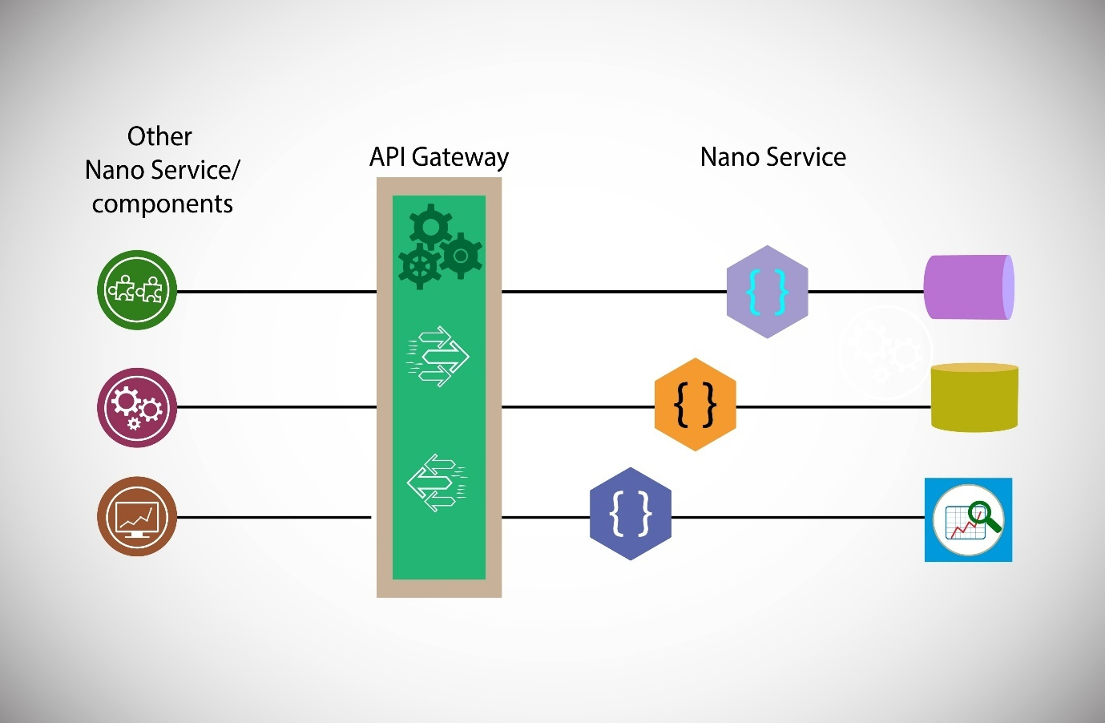
Licensed by Google
Interview Language:
- "An API Gateway is a crucial component in a microservices architecture that acts as a single entry point for all API calls."
- "It centralizes cross-cutting concerns like authentication, rate limiting, and routing, simplifying client interactions and improving security."

Database In-Depth

1. CAP Theorem
The CAP Theorem states that a distributed database system can only guarantee two of the following three properties at the same time:
- Consistency: Every read receives the most recent write or an error.
- Availability: Every request receives a response, without a guarantee that it contains the most recent write.
- Partition Tolerance: The system continues to operate despite arbitrary communication failures (partitions) between nodes.
In a distributed system, you must always account for network partitions, so you have to choose between Consistency and Availability.
Interview Language:
- "The CAP theorem is a fundamental principle for distributed databases that says we can only have two of the three guarantees: Consistency, Availability, and Partition Tolerance."
- "In a real-world, distributed system, we must always assume network partitions are possible, so we are forced to choose between a CA system (not distributed) and a CP or AP system. Most distributed databases are either AP or CP."

2. Indexes in DB
A database index is a data structure that improves the speed of data retrieval operations on a database table. It's a copy of one or more columns of a table, sorted in a specific order, along with a pointer to the original row. It works just like the index in the back of a book.
Example: In a Users table with millions of rows, searching for a user by their email without an index would require the database to scan every single row. By creating an index on the email column, the database can use the index to find the user's data almost instantly, just like finding a topic in a book's index.
Interview Language:
- "A database index is a data structure that allows for fast lookups of data, similar to an index in a book."
- "It's a key tool for optimizing read performance, but it comes with a trade-off: every write to an indexed column will also require an update to the index, which adds overhead."

3. Data Replication and Migration
- Replication: The process of copying data from one database server (master) to other database servers (replicas or slaves). The replicas can be used for reading, distributing the read load, and providing a hot standby in case the master fails.
- Migration: The process of moving data from one location to another, typically from an old database or schema to a new one. This often happens when upgrading a system or changing database providers.
Example: A popular application uses a master-slave replication setup. All write operations (creating new data) go to the master database, while read operations (like fetching a profile) are distributed across multiple replicas. This prevents the master from being overwhelmed by read traffic.
Interview Language:
- "We use data replication to improve read scalability, fault tolerance, and data availability by creating multiple copies of our data."
- "A common approach is master-slave replication, where writes go to the master and reads can be served by the slaves."

4. Partitioning and Sharding
- Partitioning: Dividing a single large database into smaller, more manageable logical pieces, often on the same server. This is a local optimization strategy.
- Sharding: A form of horizontal partitioning that splits a single logical database into multiple, independent database servers (shards). Each shard holds a subset of the total data and is completely independent.
Example:
- Partitioning: A large Orders table could be partitioned by the order's creation year. This keeps the table on a single server but makes queries for a specific year faster.
- Sharding: A user database for a global application could be sharded by the user's geographical location, with all US users on one shard and all European users on another. This distributes the database load across multiple machines.
Interview Language:
- "Sharding is a technique we use to horizontally scale a database by distributing data across multiple servers."
- "It's a way to handle datasets that are too large for a single machine and is a key strategy for scaling a database for a high-traffic application."

5. SQL vs. NoSQL
- SQL (Relational Databases): Use a structured, tabular schema with rows and columns. They enforce strict data types and relationships (e.g., foreign keys). Examples: MySQL, PostgreSQL. They are great for applications that require strong data consistency and complex joins.
- NoSQL (Non-relational Databases): Offer flexible, non-tabular schemas. They are designed to scale horizontally and can handle large volumes of unstructured data. Examples: MongoDB (document), Redis (key-value), Cassandra (column-family). They are ideal for high-volume, low-latency, and rapidly changing data.
Example:
- SQL: A banking application uses a relational database to ensure every transaction is strongly consistent and adheres to strict schema rules.
- NoSQL: A social media platform uses a NoSQL database to store user profile data, which has a flexible and ever-changing structure.
Interview Language:
- "The choice between SQL and NoSQL depends on the use case. SQL databases are best for structured data and strong transactional consistency."
- "NoSQL databases are more flexible and better suited for unstructured data, high scalability, and fast read/write operations."

Cache

1. What is Cache? Redis vs Memcache
A cache is a high-speed data storage layer that holds a subset of data, typically transient in nature, to reduce latency. It stores frequently accessed data in memory so that future requests for that data are served much faster than from the primary database.
- Redis: An in-memory data structure store. It supports various data types (strings, lists, sets, hashes), can be configured for data persistence, and provides robust replication and clustering.
- Memcached: A simple, in-memory key-value cache. It is very fast and efficient for basic caching but lacks the rich data types and persistence of Redis.
Example: A user's profile information is stored in a database. To avoid hitting the database for every profile view, the application first checks the Redis cache. If the profile is there (a cache hit), it's returned instantly. If not (a cache miss), the application fetches the data from the database, and stores it in Redis for next time.
Interview Language:
- "A cache is a temporary, high-speed storage that sits in front of a slower data store, like a database, to reduce latency and database load."
- "We would use Redis over Memcached for more advanced use cases that require complex data structures or data persistence."

2. Cache Invalidation Strategies
These are methods for ensuring the cache doesn't serve stale data.
- Time-based: Data is automatically expired after a specific Time to Live (TTL).
- Write-through: Every write operation is done to both the cache and the database simultaneously.
- Write-back: Writes are only done to the cache, and the cache later asynchronously writes the data to the database. This is faster but carries the risk of data loss if the cache fails before writing to the database.
- Manual Invalidation: The application explicitly sends a command to remove or update data in the cache after a write operation to the database.
Example: When a user updates their profile, the application first updates the database. It then sends a command to the cache to manually invalidate the cached profile data, ensuring that the next read will get the fresh data from the database.
Interview Language:
- "Cache invalidation is a critical part of caching to prevent serving stale data."
- "We often use a combination of strategies, like Time-based invalidation for frequently changing data and manual invalidation on a successful write to the database."

3. Cache Eviction Policies
When the cache is full, a policy is needed to decide which data to remove to make space for new data.
- Least Recently Used (LRU): The policy removes the item that has not been accessed for the longest time. It's based on the idea that recently used items are more likely to be used again.
- Least Frequently Used (LFU): The policy removes the item that has the lowest access count. It's based on the idea that less popular items should be evicted first.
Example: A cache has a limited size. Using an LRU policy, if a new item needs to be added and the cache is full, the item that was accessed the longest time ago is removed to make room.
Interview Language:
- "Cache eviction policies determine which data to remove when the cache is full."
- "LRU is a common and effective policy because it assumes temporal locality—that recently used data will be used again soon."

4. Cache Placement
Where you place the cache depends on the latency and scope you're trying to optimize.
- Client-side (Browser Cache): The user's browser stores static assets like images, CSS, and JavaScript files to avoid re-downloading them on subsequent visits.
- CDN/Edge Cache: A Content Delivery Network (CDN) places copies of your static assets on servers closer to the user, reducing latency.
- Application Layer (In-Memory): A dedicated cache server (like Redis) that sits between the application and the database. This is a common pattern for caching frequently requested data.
- Database Layer: The database itself may have a built-in cache for frequently executed queries or data blocks.
Example: A user in Europe visiting a website hosted in the US would first hit a CDN server in Europe to get static assets. When they make an API call to get their profile, the application first checks the Application Layer cache (Redis). Finally, if it's a cache miss, the query goes to the Database Layer.
Interview Language:
- "We can place caches at different layers to optimize for different things. CDN caching is great for static content and reducing network latency."
- "Application-level caching using Redis is where we would store dynamic data like user profiles to reduce the load on our database."

Load-Balancers

1. Types of Load Balancers (Layer 4 vs Layer 7 LB)
Load balancers distribute traffic across multiple servers. The two main types are differentiated by which network layer they operate on.
- Layer 4 (Transport Layer): Operates on the transport layer (TCP/UDP). It's simple and fast, distributing traffic based on IP addresses and port numbers without inspecting the content of the request.
- Layer 7 (Application Layer): Operates on the application layer (HTTP/HTTPS). It can inspect the content of the request (headers, URLs, cookies) to make more intelligent routing decisions. It can also perform tasks like SSL termination and content compression.
Example:
- Layer 4 LB: A Layer 4 load balancer distributes incoming TCP traffic for an application based on the IP address and port, ensuring even distribution among backend servers.
- Layer 7 LB: A Layer 7 load balancer can route requests for /images to one group of servers and requests for /api to another group of servers, based on the URL path.
Interview Language:
- "We use a Layer 7 load balancer for our web application because it gives us more flexibility to make intelligent routing decisions based on the request's content, and it can also handle SSL termination for us."
- "A Layer 4 load balancer is simpler and faster but can only route based on IP and port."

2. Load Balancing Algorithms (Stateful vs Stateless)
These algorithms determine which backend server receives an incoming request.
- Stateless:
  - Round Robin: Distributes requests sequentially to each server in a rotating manner.
  - Least Connections: Sends new requests to the server with the fewest active connections.
- Stateful:
  - Consistent Hashing: Uses a hash of the request (e.g., user ID, IP address) to route it to the same server every time. This is useful for caching and maintaining session state.
  - IP Hash: A simpler version of consistent hashing where the source IP address is used to determine the server. This ensures a client always connects to the same server.
Example: In a stateless system with a round robin algorithm, user A's first request goes to server 1, and their second request goes to server 2. In a stateful system using IP hash, both of user A's requests would be consistently routed to the same server.
Interview Language:
- "We use a Least Connections algorithm to ensure traffic is distributed to the least busy servers, improving overall performance."
- "For our user-facing sessions, we may use a stateful algorithm like consistent hashing to ensure a user's requests are always routed to the same server to maintain session state."

3. Rate Limiting
Rate limiting is a technique to control the number of requests a client can make to an API within a specific time frame. Its purpose is to protect services from being overwhelmed by traffic, prevent abuse, and ensure fair usage.
Example: An API might allow a client to make a maximum of 100 requests per minute. If a client exceeds this limit, the rate limiter will block subsequent requests and return a 429 Too Many Requests status code.
Interview Language:
- "We implement rate limiting to protect our services from denial-of-service (DDoS) attacks and to ensure that a single client can't monopolize our resources."
- "It's a crucial security and stability mechanism for public APIs."

4. Consistent Hashing
Consistent hashing is a specialized hashing technique that minimizes the number of keys that need to be remapped when a hash table (or in this case, a set of servers) is resized. Instead of a direct mapping, it maps both the servers and the data to a circular ring.
Example: In a system with 100 servers, if one server fails, a normal hashing approach would remap 1/100th of the requests. With consistent hashing, only the data from the failed server needs to be remapped to its neighbors on the ring, minimizing the impact on the overall system.
Interview Language:
- "Consistent hashing is an elegant solution for distributing requests or data to a dynamic set of servers."
- "It's particularly useful for distributed caches and load balancers because it ensures that when a server is added or removed, we only have to remap a small fraction of the data, rather than the entire dataset."

Networks

1. Core Networking Protocols - TCP/UDP/IP
- IP (Internet Protocol): The fundamental protocol that defines how data is addressed and routed from a source to a destination.
- TCP (Transmission Control Protocol): A reliable, connection-oriented protocol built on top of IP. It ensures data is delivered accurately and in order by requiring acknowledgements from the receiver. It's slower but safer.
- UDP (User Datagram Protocol): A connectionless protocol. It's faster because it doesn't require acknowledgements or error checking, but it doesn't guarantee delivery or order.
Example:
- TCP: Used for web Browse, file transfers, and email, where data integrity is critical.
- UDP: Used for real-time applications like video streaming, online gaming, and voice calls, where speed is more important than ensuring every single packet arrives.
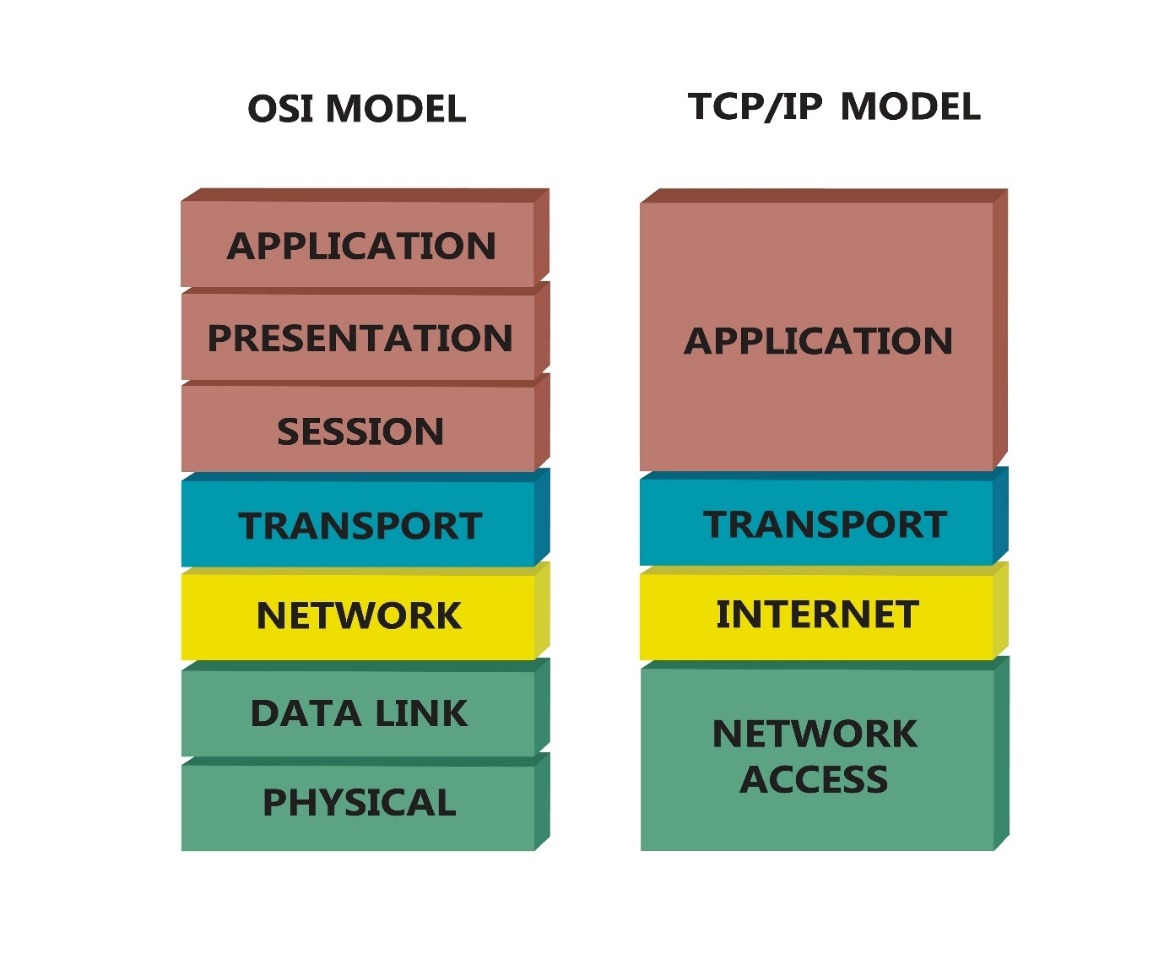
Licensed by Google
Interview Language:
- "TCP is a reliable, connection-oriented protocol we use for things like HTTP requests because we need to ensure all the data arrives correctly."
- "UDP is a fast, connectionless protocol, which would be a better choice for real-time audio or video streaming where we can tolerate some packet loss."

2. HTTP vs. HTTPS
- HTTP (Hypertext Transfer Protocol): The protocol used for communication between web servers and web browsers. Data is sent as plain text, making it vulnerable to eavesdropping.
- HTTPS (HTTP Secure): A secure version of HTTP that encrypts the communication using SSL/TLS. It prevents unauthorized parties from viewing or tampering with the data in transit.
Example: When a user logs in to a website, the login credentials must be sent over HTTPS to ensure they are encrypted and cannot be intercepted by hackers. An unencrypted HTTP connection would send the password in plain text.
Interview Language:
- "HTTPS is simply HTTP with an added layer of security using SSL/TLS encryption."
- "We always use HTTPS for all of our services to ensure data privacy and integrity, which is a non-negotiable security requirement."

3. Websockets
Websockets are a communication protocol that provides a full-duplex (two-way) communication channel over a single, long-lived TCP connection. Unlike HTTP, which is a stateless request/response protocol, Websockets allow for persistent real-time communication between a client and a server.
Example: A chat application uses Websockets. When a user sends a message, it's immediately sent to the server. The server then pushes that message to all other clients in the chat room without them having to constantly poll for new messages.
Interview Language:
- "We would use Websockets for real-time, bidirectional communication between the client and server, for applications like live chat, notifications, or collaborative editing."
- "The key benefit is that it avoids the overhead of constantly re-establishing connections, which is what would happen with traditional HTTP polling."

4. WebRTC (Web Real-Time Communication)
WebRTC is an open-source project that enables real-time, peer-to-peer audio, video, and data communication directly between browsers without the need for an intermediate server to handle the media stream. It's a suite of APIs that allows browsers to connect and stream data to each other.
Example: In a video conferencing app like Google Meet or Zoom, the audio and video streams are often sent directly between the participants' browsers using WebRTC, significantly reducing latency and server costs. The server is still used for the initial signaling and to help peers connect, but not for the actual media transfer.
Interview Language:
- "WebRTC is a technology that facilitates peer-to-peer audio/video communication directly in the browser."
- "It's a game-changer for applications like video calls and live streaming, as it bypasses the need for a central media server and greatly reduces latency."

Monolith vs. Microservice

1. Monolith vs. Microservice
- Monolith: A monolithic application is a single, large, and tightly coupled application. All components—the user interface, business logic, and data layer—are part of a single codebase and are deployed together.
- Microservice: A microservices architecture is an approach where a large application is broken down into a suite of small, independent, and loosely coupled services. Each service performs a single business function and can be developed and deployed independently.
Interview Language:
- "We use a microservices architecture to build our system, which allows us to have smaller, independently deployable services that are easy to develop and scale."
- "A monolith is a single, tightly coupled application, which can be simpler to start but becomes difficult to manage and scale as it grows."

2. Trade-offs with Microservices
Microservices offer significant benefits but come with their own set of challenges.
- Pros:
  - Scalability: Services can be scaled independently.
  - Independent Deployment: A change in one service doesn't require redeploying the entire application.
  - Technology Diversity: Different services can be written in different programming languages.
- Cons:
  - Operational Complexity: More services mean more things to manage, monitor, and deploy.
  - Distributed System Issues: Handling distributed transactions, network latency, and service discovery becomes more complex.
  - Data Consistency: Maintaining data consistency across multiple services can be a challenge.
Interview Language:
- "While microservices offer great benefits in terms of scalability and independent deployment, they introduce significant operational complexity and challenges related to distributed systems."

3. Containerization Concepts
Containerization is a method of packaging an application and all its dependencies (libraries, frameworks, configurations) into a single, isolated, and portable unit called a container. This ensures the application runs consistently regardless of the environment it's deployed on. Docker is a popular tool for building and managing containers.
Example: An application is built and packaged into a Docker container. This container can then be run on a developer's laptop, a staging server, or a production server, and it will behave exactly the same way. This eliminates the "it works on my machine" problem.
Interview Language:
- "We use containerization with Docker to package our services and their dependencies. This provides a consistent and isolated runtime environment, which simplifies our deployment process."
- "It's a core component of our CI/CD pipeline, as it ensures our code will run the same way everywhere."

Message Queue

1. Sync vs. Async
- Synchronous: The sender sends a request and waits for a response before continuing. It's a blocking operation.
- Asynchronous: The sender sends a request and continues with its own work without waiting for a response. The response is handled at a later time.
Example:
- Sync: A user fills out a form and clicks submit. The browser waits for a response from the server before displaying a success message.
- Async: A user uploads a video to a service. The service immediately tells the user "upload received," but the actual video processing happens asynchronously in the background.
Interview Language:
- "We use asynchronous communication with message queues for long-running or non-critical tasks to improve application responsiveness and decouple services."
- "This prevents our main service from being blocked while waiting for a dependency to complete a task."

2. Pub-Sub Model
The Publish-Subscribe (Pub-Sub) model is a messaging pattern where senders (publishers) send messages to a channel (topic) without knowing who will receive them, and receivers (subscribers) listen to that channel to get the messages. This provides a powerful way to decouple services.
Example: An e-commerce system uses a Pub-Sub model. When an Order is placed (published to an orders topic), different services—like the Inventory service, Shipping service, and Billing service—can subscribe to that topic and process the order independently.
Interview Language:
- "We use a Pub-Sub model to enable event-driven communication between our services. It allows us to loosely couple our services, so they don't need to know about each other to communicate."

3. Retry, Acknowledgement, Dead Letter Queues
These concepts are essential for building reliable messaging systems.
- Acknowledgement: A consumer sends an acknowledgment to the message queue after successfully processing a message. This tells the queue it can safely delete the message.
- Retry: If a consumer fails to process a message, the message is typically put back into the queue for a limited number of retries.
- Dead Letter Queue (DLQ): A queue where messages are moved after failing to be processed a maximum number of times. This prevents a "poison pill" message from perpetually blocking the main queue.
Example: A consumer tries to process a message but fails due to a temporary database issue. The message is retried. After three failed attempts, the message is moved to a Dead Letter Queue for later inspection and manual troubleshooting.
Interview Language:
- "We ensure message processing is reliable by using acknowledgements and implementing a retry mechanism."
- "Any messages that repeatedly fail are moved to a Dead Letter Queue, which allows us to prevent queue blocking and investigate the root cause of the failure."

4. RabbitMQ, Kafka, SQS vs. SNS
- RabbitMQ: A traditional message broker that is great for complex routing and guaranteeing message delivery. It uses a push-based model where messages are pushed to consumers.
- Kafka: A distributed streaming platform designed for high-throughput, fault-tolerant data pipelines. It treats messages as a commit log, allowing multiple consumers to read the same message. It's pull-based.
- SQS (Simple Queue Service): An AWS-managed queueing service. It's great for decoupling components and is a simple, highly scalable queue. It's a one-to-one service.
- SNS (Simple Notification Service): An AWS-managed Pub-Sub service. It's a one-to-many service that can fan out messages to multiple subscribers, including SQS queues, Lambda functions, or email.
Interview Language:
- "We use Kafka for our high-throughput data pipelines and event streaming, as it's built for scale and durability."
- "For simpler task queues, we would use something like SQS, which is a highly available and managed service for decoupling components."
- "The key difference between SQS and SNS is that SQS is a queueing service (one-to-one), while SNS is a Pub-Sub service (one-to-many)."

5. Idempotency
Idempotency is the property of a request or operation that, when executed multiple times, has the exact same effect as executing it once. This is crucial in distributed systems and with message queues to handle retries and prevent duplicate operations.
Example: A user's bank transfer request could be sent twice due to a network issue. If the transfer API is not idempotent, the user could be charged twice. By making the API idempotent (e.g., using a unique transaction ID), the second request will be ignored if the first one was already successfully processed.
Interview Language:
- "Idempotency is a crucial concept for designing robust APIs, especially in a distributed system where messages might be redelivered or retried."
- "We ensure our payment processing API is idempotent by using a unique transaction key, so that even if a request is received multiple times, the transaction is only executed once."

Security

1. Different Authorization Protocols
- Authentication is about verifying a user's identity ("Are you who you say you are?").
- Authorization is about granting a user permission to access a resource ("Are you allowed to do this?").
- OAuth 2.0: A popular authorization framework that allows a user to grant a third-party application limited access to their resources on another service without sharing their password. Think of "Login with Google" or "Login with Facebook."
- JWT (JSON Web Tokens): A compact, URL-safe means of representing claims to be transferred between two parties. JWTs are often used after a successful authentication to securely transmit a user's identity and permissions to the application, which can then be used for subsequent requests to authorize access to resources.
Example: A user logs in to a website and receives a JWT. For every subsequent request, the browser includes this token in the header. The application validates the token to confirm the user's identity and permissions before granting access to a resource.
Interview Language:
- "We use OAuth 2.0 for our third-party integrations to securely delegate access to user data without ever handling user passwords."
- "For our internal API calls, we use JWTs to securely pass a user's authenticated state and permissions between services."

API Evolution and Backward Compatibility
API evolution is the process of updating an API over time. Backward compatibility is the ability of a new API version to work with clients built for an older version. It's a critical concept in API design to avoid breaking existing applications and to ensure a smooth transition for developers.

URI Versioning
URI Versioning is a common practice where the API version is explicitly included in the URL. This allows different versions of an API to coexist, so a client can continue to use an older version while new clients can adopt the latest one.
Explanation: By placing the version number (e.g., v1, v2) directly in the URI, you create a distinct endpoint for each API version. This provides a clear, explicit way for clients to request a specific version of the API. When you need to make a breaking change, you can create a new version (e.g., /api/v2/resource), while leaving the old version (/api/v1/resource) untouched for existing clients.
Example:
- Old API: https://api.example.com/api/v1/users/123
- New API: https://api.example.com/api/v2/users/123 The v1 endpoint remains available for older clients, while new clients can be built to use the v2 endpoint, which might have a different response structure or new functionality.
Interview Language:
- "We use URI versioning to manage our API evolution. This strategy involves embedding the version number directly into the URL, like /api/v1/users."
- "The main benefit is that it allows us to deploy breaking changes without impacting existing clients, providing a clear path for them to upgrade when they are ready."
- "It's a straightforward approach that makes it easy for developers to see which version they are interacting with."

Adding and Removing Fields
When evolving an API, careful consideration is needed for how fields are added or removed to maintain backward compatibility.
Adding Fields: Explanation: Adding new, optional fields to an API response is generally considered a non-breaking change. Older clients that don't know about the new fields will simply ignore them, while newer clients can take advantage of the new data.
Example:
- v1 Response:
JSON
{
"id": 123,
"name": "John Doe"
}
- v2 Response (with new field):
JSON
{
"id": 123,
"name": "John Doe",
"email": "john.doe@example.com"
}
An older client expecting only id and name will still work perfectly with the v2 response.
Removing Fields: Explanation: Removing fields is a breaking change and must be handled with extreme care. If an older client depends on a removed field, its functionality will break. The best practice is to deprecate fields first, giving developers a warning period to update their code before the field is completely removed in a new API version.
Example: You decide to remove the name field from the API response and replace it with separate firstName and lastName fields.
- Bad approach: Simply remove name in the new version. This will break older clients.
- Good approach: In v2, you keep the name field but mark it as deprecated in the API documentation. You add the new firstName and lastName fields. In a future v3 of the API, you can then safely remove the name field.
Interview Language:
- "When we add new fields to an API, we ensure they are optional to maintain backward compatibility, as older clients will simply ignore them."
- "Conversely, removing a field is a breaking change. We must use a deprecation strategy where we first mark the field for removal in the current version and only remove it in a new, major version of the API."
- "This approach gives developers adequate time to adapt to changes and prevents sudden application failures."

Retry Policies
Retry policies are essential strategies for building resilient applications that can handle temporary failures, such as network timeouts or a dependent service being temporarily unavailable. Instead of failing immediately, the application attempts the operation again after a short delay.

Exponential Backoff
Exponential backoff is a retry strategy where the waiting time between retries increases exponentially. This approach is highly effective in preventing a failed service from being overwhelmed with repeated requests, which could worsen the outage. It gives the service a chance to recover gracefully.
Explanation: The first retry might occur after a 1-second delay, the second after a 2-second delay, the third after a 4-second delay, and so on. A random jitter can be added to these wait times to prevent a "thundering herd" problem, where multiple clients all retry at the exact same moment.
Example: An application fails to connect to a database. It retries after 1 second, then after 2 seconds, then 4 seconds, and finally gives up after 8 seconds. This staggered approach ensures that if the database is overloaded, the application isn't adding to the problem by sending constant requests.
Interview Language:
- "We use exponential backoff with jitter for our retry policy to handle transient network failures."
- "The core idea is to increase the delay between retries exponentially to avoid overwhelming a temporarily unavailable service and to give it time to recover."

Linear Backoff
Linear backoff is a simpler retry strategy where the waiting time between retries increases by a constant amount.
Explanation: Instead of an exponential increase, the delay increases by a fixed value. For example, the first retry might be after 1 second, the second after 2 seconds, and the third after 3 seconds. While not as sophisticated as exponential backoff for preventing server overload, it's a straightforward and predictable approach.
Example: A consumer service fails to process a message from a queue. It's configured to retry the message every 5 minutes. This fixed, linear delay ensures the message is eventually processed without adding a heavy load on the system.
Interview Language:
- "Linear backoff is a more predictable retry strategy where the delay between retries increases by a constant amount."
- "It's a simple and effective approach for scenarios where we can be reasonably confident the dependency will recover without being overwhelmed."

Circuit Breakers
A Circuit Breaker is a design pattern that prevents an application from repeatedly calling a failing service. It acts like an electrical circuit breaker: when it detects that a service is failing, it "trips" the circuit and stops all future requests to that service for a set period.
Explanation: The circuit breaker has three states:
- Closed: All requests are allowed to pass through to the service. If the failure rate exceeds a threshold, the circuit trips to the Open state.
- Open: The circuit is "tripped," and requests are immediately rejected with an error without even attempting to call the failing service. A timer is started.
- Half-Open: After the timer expires, a small number of test requests are allowed to pass through. If these requests succeed, the circuit returns to the Closed state. If they fail, it returns to the Open state.
Example: An e-commerce service relies on a third-party payment gateway. The gateway starts timing out frequently. The circuit breaker detects this and immediately "opens," causing all new payment requests to fail fast. This protects the e-commerce service from a cascade of timeouts and gives the payment gateway time to recover.
Interview Language:
- "A circuit breaker is a critical pattern for preventing cascading failures in a distributed system."
- "It acts as a shield, preventing us from making repeated requests to a failing service. It fails fast and gives the downstream service time to recover, which is a much better user experience than waiting for a long timeout."

Retrying after OAuth Token Refresh
This is a specific retry scenario for applications that use OAuth 2.0 for authorization. It handles the situation where an access token expires during a user's session.
Explanation: When an application tries to make an API call, it includes the user's access token. If the API returns an error indicating the token has expired, the application doesn't just fail. It uses the stored refresh token to request a new access token from the authentication server. Once the new token is acquired, the application retries the original API request with the fresh token.
Example: A mobile app for a social media platform has a user session. A user's access token expires while they are trying to post a photo. The app gets a 401 Unauthorized error. Instead of asking the user to log in again, the app uses the refresh token to get a new access token. It then automatically retries the photo upload with the new, valid token, and the user never knows there was an issue.
Interview Language:
- "In our authentication flow, we implement a retry mechanism specifically for expired OAuth tokens."
- "If a request fails due to an expired token, the application uses the refresh token to silently obtain a new access token and then automatically retries the original request."
- "This ensures a seamless user experience by avoiding unnecessary re-authentication prompts."

What is Swift?
Swift is a modern, powerful, and intuitive programming language developed by Apple for building applications across all Apple platforms, including iOS, macOS, watchOS, and tvOS. It was introduced in 2014 as a replacement for Objective-C, bringing a safer, faster, and more expressive way to write code.

Key Features of Swift
- Safety: Swift's design eliminates entire classes of unsafe code. It enforces strict type checking and helps prevent common programming errors like null pointer exceptions. Swift code is designed to be more reliable and easier to read and debug.
- Performance: Swift is compiled into native machine code, making it incredibly fast. Its performance is comparable to C++, and it's optimized for modern hardware and memory management.
- Modern Syntax: The syntax is clean, concise, and easy to read. It borrows ideas from languages like Python and Ruby, but with a focus on type safety and robust error handling. This makes it more approachable for new developers.
- Interoperability with Objective-C: Swift can be used in the same project as Objective-C, allowing developers to gradually migrate existing applications or use existing Objective-C libraries and frameworks.
- Open Source: Swift is an open-source language, maintained by Apple and a large community. This allows it to be used on other platforms, such as Linux and Windows, and has led to its use in server-side development.

Swift Example: A Simple iOS App
Imagine you want to create a basic iOS app that shows a welcome message.
Swift
import UIKit

class ViewController: UIViewController {

@IBOutlet weak var messageLabel: UILabel!

override func viewDidLoad() {
super.viewDidLoad()

// This is where you put code that runs when the view loads
messageLabel.text = "Hello, Swift!"
}
}
Explanation: This code snippet shows a simple view controller in an iOS app. import UIKit brings in Apple's framework for building user interfaces. The messageLabel is a UI element (a label) connected from the user interface. The viewDidLoad() function is a lifecycle method that is called when the app's view loads. Inside this function, we set the text of the messageLabel to "Hello, Swift!".

Interview Language
When discussing Swift in an interview, use language that highlights its key strengths and your practical knowledge.
- "Swift is Apple's modern programming language for developing applications across all their platforms, including iOS, macOS, and watchOS."
- "I appreciate Swift's focus on safety and performance. Its strong type system and optional chaining help prevent common bugs, making the code more reliable."
- "The syntax is also very expressive and readable, which speeds up development and makes it easier for teams to collaborate."
- "Swift is a core part of the Apple ecosystem. For building iOS applications, I primarily use Swift in combination with the UIKit and SwiftUI frameworks to build the user interface."
- "I am also familiar with Swift's interoperability with Objective-C, which is important when working with older codebases or third-party libraries."

Security Best Practices for UI/Frontend
Frontend security is crucial because the user's browser is often the first point of contact with your application. A compromised frontend can lead to data theft, session hijacking, and defacement.

1. DDoS Attacks
A Distributed Denial-of-Service (DDoS) attack is a malicious attempt to disrupt the normal traffic of a targeted server, service, or network by overwhelming the target with a flood of internet traffic from multiple sources. While DDoS attacks typically target the backend, a frontend can be an entry point for attacks that consume client-side resources.
Explanation: In a DDoS attack, an attacker uses a network of compromised machines (a "botnet") to flood a target with traffic. For the frontend, this can manifest as an attacker forcing browsers to execute heavy scripts or make a large number of requests simultaneously, effectively rendering the website unusable for legitimate users.
Example: An attacker uses a botnet to repeatedly send requests to your website's public APIs or to execute complex JavaScript on a page. This could lead to slow loading times or a complete server crash.
Interview Language:
- "While DDoS attacks are primarily a backend concern, a well-designed frontend can mitigate their impact by using a CDN and implementing robust rate-limiting on client-side requests."
- "The goal is to prevent the client from being used as a vector for resource exhaustion."

2. Authentication and Authorization
- Authentication: Verifies the user's identity ("Are you who you say you are?"). In the frontend, this involves capturing user credentials and sending them to the backend for verification.
- Authorization: Determines what a verified user is allowed to do ("Do you have permission to access this resource?"). The frontend is responsible for showing or hiding UI elements based on the user's permissions, but it should never be the sole source of truth for authorization.
Explanation: The frontend should handle the user-facing part of the security process, but the actual security checks must always be done on the backend. This is because a malicious user can easily bypass frontend checks by modifying the client-side code.
Example: A user logs in, and the backend returns a JSON Web Token (JWT). The frontend stores this JWT and includes it in the header of subsequent requests. When the user tries to access a protected page, the frontend might hide a "Delete" button if the user's role doesn't permit it. However, the backend must perform its own check on the JWT to ensure the user is authorized to perform the delete operation.
Interview Language:
- "The frontend handles the user experience for authentication but the actual verification must happen on the backend."
- "For authorization, the frontend is responsible for the UI, but we must never trust client-side data. All authorization checks are re-verified on the server to prevent a user from bypassing our security."

3. CSP (Content Security Policy)
A Content Security Policy (CSP) is an HTTP response header that defines which resources the browser is allowed to load for a given page. It's a powerful tool to prevent Cross-Site Scripting (XSS) attacks and other forms of code injection.
Explanation: The CSP header specifies a list of trusted domains from which scripts, styles, images, and other resources can be loaded. If a script tries to load from an untrusted source, the browser will block it. This provides a strong defense against attackers injecting malicious scripts.
Example: A website's CSP header might specify that scripts can only be loaded from self (the website's own domain) and cdn.example.com. If an attacker successfully injects a <script> tag that points to evil-hacker.com, the browser will refuse to load that script, neutralizing the attack.
Interview Language:
- "A Content Security Policy is a key security measure that uses an HTTP header to tell the browser which sources are trusted for content."
- "This effectively mitigates XSS attacks by preventing the browser from executing scripts from untrusted domains, which significantly reduces our attack surface."

4. CORS (Cross-Origin Resource Sharing)
Cross-Origin Resource Sharing (CORS) is a browser security feature that restricts how a web page in one domain can request resources from another domain. It prevents a malicious website from making unauthorized requests to your APIs on behalf of a logged-in user.
Explanation: When a browser on www.site-a.com tries to make an API request to www.api-b.com, the browser first sends a "preflight" request (an OPTIONS HTTP request) to the API. The API then responds with a header (Access-Control-Allow-Origin) that tells the browser whether it's safe to proceed with the actual request. If the origins don't match or aren't explicitly allowed, the browser blocks the request.
Example: An attacker creates a website www.malicious.com and tries to make an API request to www.yourbank.com/transfer from a user's browser. Because of CORS, the browser will see that www.malicious.com is not in the list of allowed origins for www.yourbank.com and will block the request, preventing the attack.
Interview Language:
- "CORS is a browser security mechanism that controls cross-origin requests to our APIs."
- "We use CORS headers on our backend to specify which origins are allowed to make requests, which is a crucial defense against Cross-Site Request Forgery (CSRF)."

5. Man-in-the-Middle (MITM)
A Man-in-the-Middle (MITM) attack occurs when an attacker secretly intercepts and relays communications between two parties who believe they are communicating directly with each other. The attacker can listen in on the conversation, and even alter the data.
Explanation: The most effective defense against MITM attacks is to use encryption. By ensuring all communication between the browser and the server is encrypted, an attacker who intercepts the traffic will only see garbled, unreadable data.
Example: An attacker sets up a fake Wi-Fi network at a coffee shop. When a user connects and tries to access their bank's website, the attacker intercepts the traffic. If the website uses HTTPS, the communication is encrypted, and the attacker cannot steal the login credentials. If the website uses HTTP, the credentials are sent in plain text and are easily compromised.
Interview Language:
- "The primary defense against a Man-in-the-Middle attack is to enforce HTTPS for all traffic."
- "SSL/TLS encryption ensures that even if an attacker intercepts our communication, the data remains secure and unreadable."

Performance and Optimization
Frontend performance is critical for user experience and search engine optimization.

1. Asset Optimization
Asset optimization is the process of minimizing the size and improving the delivery of static assets like images, CSS, and JavaScript files.
Explanation: This includes techniques such as:
- Image Compression: Using tools to reduce image file size without significant loss of quality.
- Minification: Removing unnecessary characters (whitespace, comments) from CSS and JavaScript to reduce file size.
- Bundling: Combining multiple CSS and JavaScript files into a single bundle to reduce the number of HTTP requests.
Example: Instead of serving a 500KB high-resolution image, you can compress it to 50KB. Instead of serving five separate JavaScript files, you can bundle them into one, reducing five requests to a single one.
Interview Language:
- "We focus on asset optimization to reduce page load times. This involves minifying and bundling CSS and JavaScript and using efficient image formats and compression."
- "It's a foundational step for improving our application's performance."

2. Delivery Options (CDNs)
A Content Delivery Network (CDN) is a geographically distributed network of proxy servers and data centers. It's used to deliver content, like static assets, to users based on their geographical location.
Explanation: A CDN places copies of your assets on "edge servers" located all over the world. When a user requests an asset, the request is routed to the closest edge server, drastically reducing network latency.
Example: A user in India visiting a website hosted in the US would get the assets (images, CSS) from a CDN server in Mumbai, rather than waiting for the request to travel all the way to the US.
Interview Language:
- "We use a CDN to improve performance by caching our static assets at edge locations closer to our users."
- "This is a simple and highly effective way to reduce latency and improve the perceived performance of our application."

3. SSR (Server-Side Rendering)
Server-Side Rendering (SSR) is a technique where the server renders the initial HTML for a page, including all the content, before sending it to the client. This is in contrast to Client-Side Rendering (CSR), where the browser downloads a minimal HTML page and then uses JavaScript to build the content.
Explanation: SSR results in a faster "First Contentful Paint" (FCP) because the user sees the content immediately, even before the JavaScript is fully loaded. This is great for SEO and perceived performance.
Example: A blog post page is rendered on the server. The server sends a fully formed HTML document with the post's content and styling. The user's browser immediately displays the blog post while the JavaScript loads in the background, making the page interactive.
Interview Language:
- "Server-Side Rendering is a key performance strategy for us because it delivers a fully-formed HTML page to the client."
- "This results in a faster initial load time and better SEO, as search engine crawlers can easily index the content."

4. Service Workers
A Service Worker is a type of web worker that acts as a client-side proxy, running in the background and separate from the web page. It can intercept network requests, cache resources, and enable features like push notifications and offline functionality.
Explanation: Service workers are a core component of Progressive Web Apps (PWAs). They can be used to cache a website's assets, so when a user revisits the site, the browser serves the cached version, making the site load almost instantly, even with a slow network or no internet connection.
Example: A user visits an e-commerce site. The service worker caches the site's layout and product images. The next time the user visits, even if they are offline, the service worker serves the cached content, allowing them to browse the products that were cached.
Interview Language:
- "We use Service Workers to enable offline functionality and improve repeat visits."
- "By intercepting network requests and serving cached assets, they make our application more resilient and provide a native app-like experience."

5. Web Vitals
Core Web Vitals are a set of metrics defined by Google that measure a website's performance, user experience, and overall health. They are a crucial factor in search engine ranking. The three main Core Web Vitals are:
- Largest Contentful Paint (LCP): Measures when the largest content element on the page becomes visible.
- First Input Delay (FID): Measures the time from when a user first interacts with a page to the time when the browser is able to begin processing that interaction.
- Cumulative Layout Shift (CLS): Measures the visual stability of a page by quantifying unexpected layout shifts.
Explanation: These metrics provide a standardized way to measure and improve user experience. Optimizing your website for Web Vitals directly leads to better user satisfaction and higher search rankings.
Example: A large image takes a long time to load, causing a high LCP score. Optimizing the image size and using a CDN would improve the LCP. If a button appears after the page loads, pushing other content down, it would result in a high CLS score.
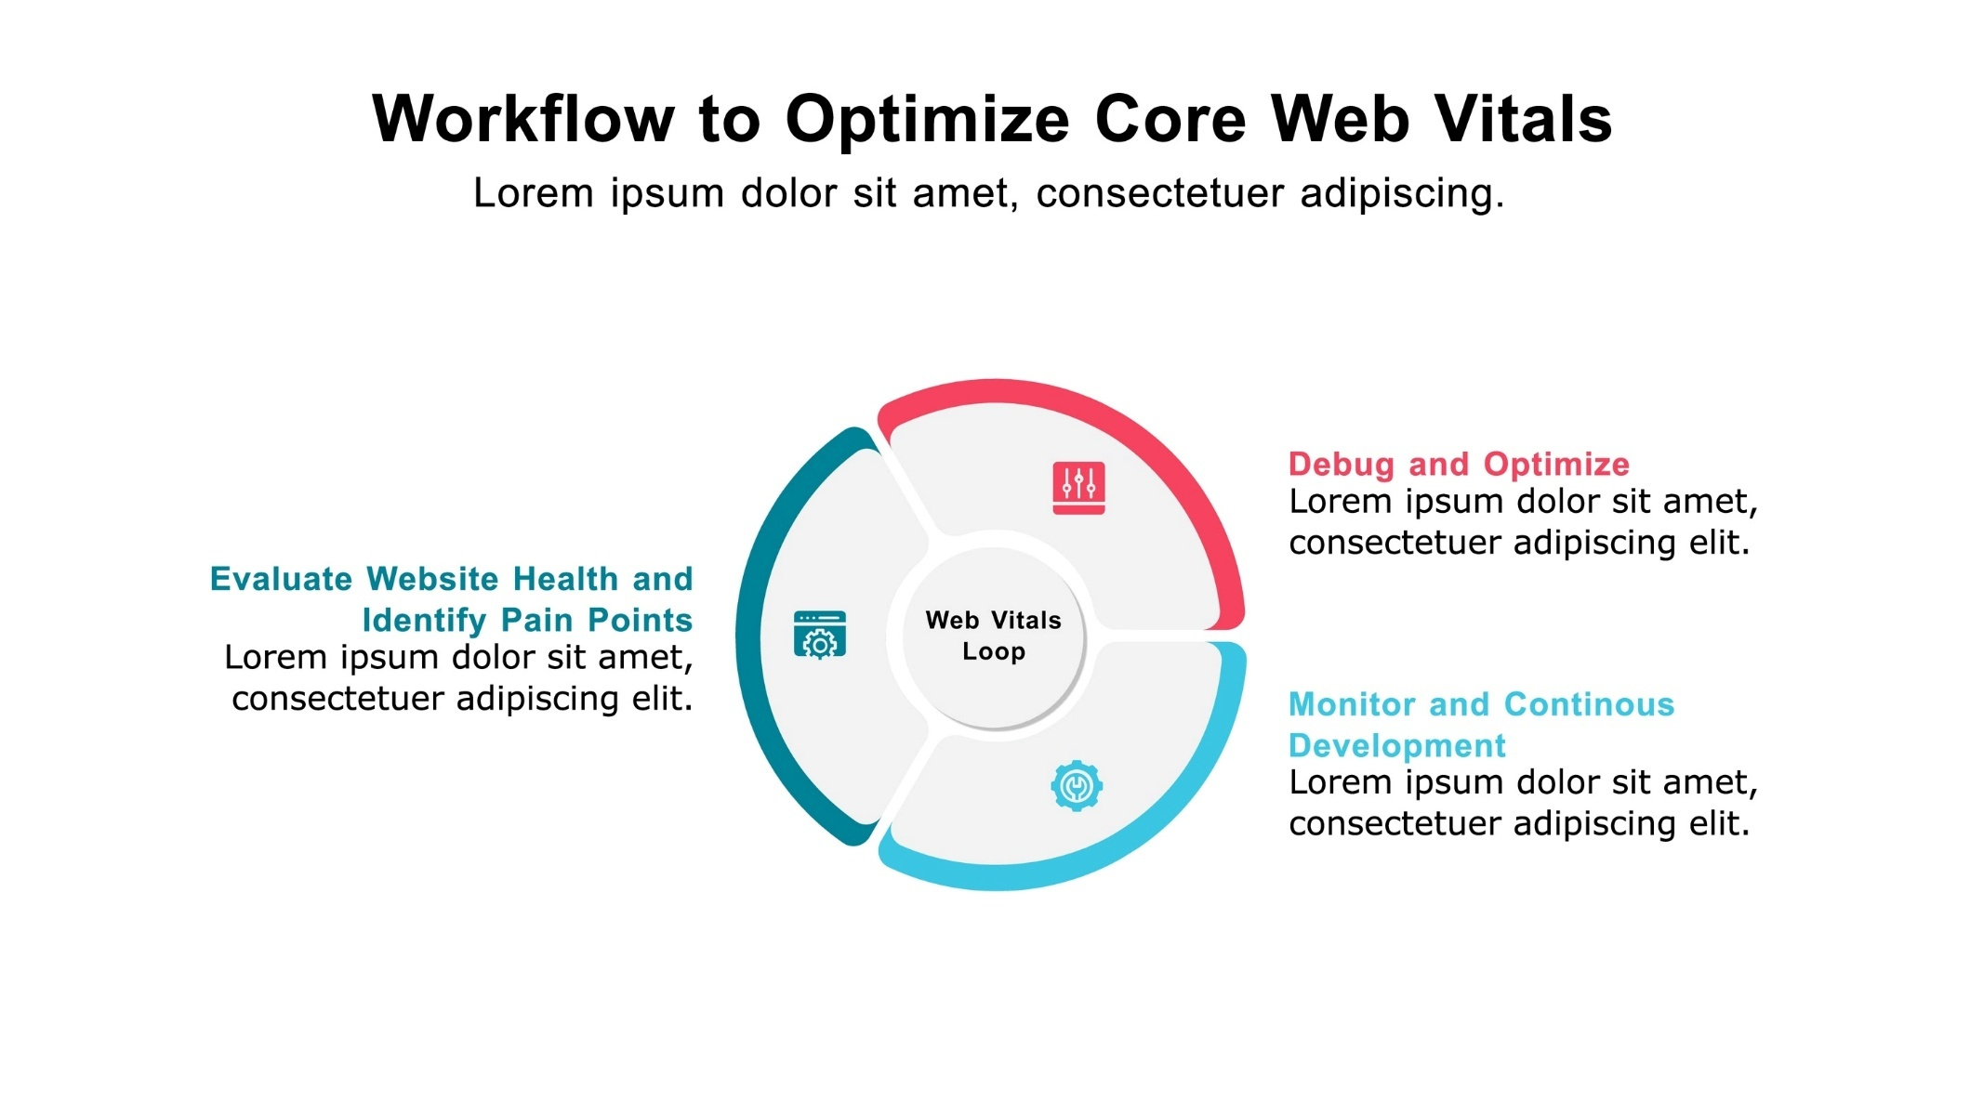
Licensed by Google
Interview Language:
- "We actively monitor our Core Web Vitals to ensure a great user experience and maintain strong SEO."
- "LCP, FID, and CLS are our key performance indicators, and we implement strategies like SSR and asset optimization to improve them."

6. Perceived Performance
Perceived performance is how fast a user feels a website is, as opposed to its actual measured speed. It's about giving users visual cues that the page is loading quickly and responding to their actions.
Explanation: While actual performance metrics are important, perceived performance is what truly impacts user satisfaction. Techniques include using loading skeletons, lazy loading images, and using animations to make transitions feel instant.
Example: When a page is loading, instead of showing a blank white screen, a "skeleton screen" is displayed. This is a grayscale version of the page's layout that gives the user an impression of a fast load, even if the content is still being fetched.
Interview Language:
- "We focus on perceived performance by using techniques like skeleton loaders and lazy loading."
- "It's about managing user expectations and making the application feel fast, which is just as important as it being fast in reality."

Testing
Testing is a critical part of the software development lifecycle to ensure quality and reliability.

1. Behavioral, Unit, Individual, and End-to-End Testing
- Unit Testing: Tests the smallest, isolated units of code (e.g., a single function).
- Individual Testing: (Often used interchangeably with Unit Testing) Focuses on a single component or small module.
- Behavioral Testing: Tests the application from a user's perspective, focusing on how a user interacts with the application.
- End-to-End (E2E) Testing: Tests the entire application flow from start to finish, simulating a user's journey across all layers (frontend, backend, database).
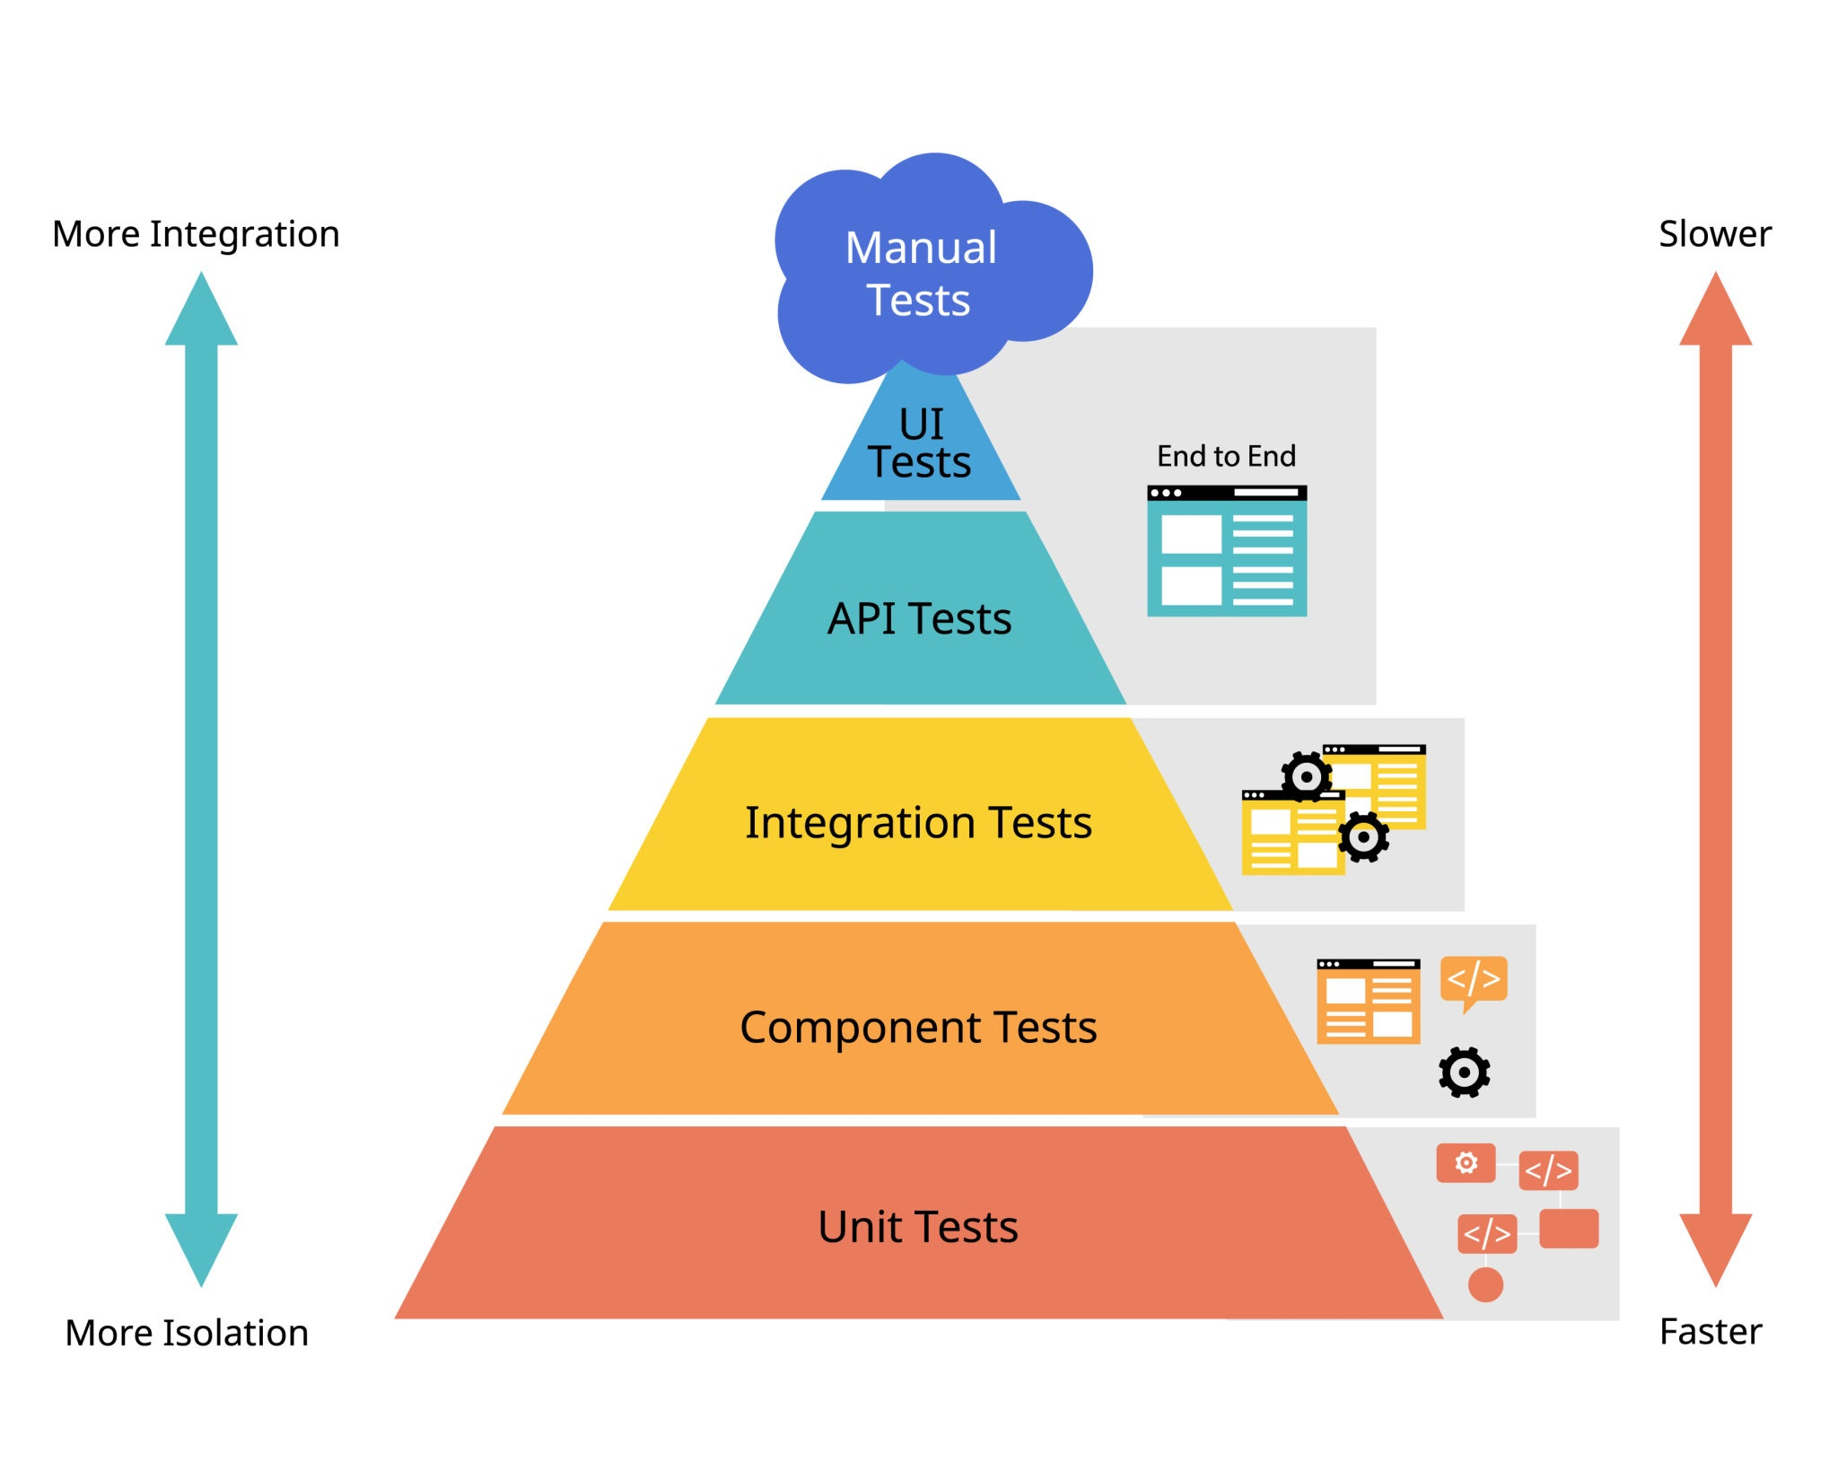
Licensed by Google
Interview Language:
- "We use a testing pyramid approach, starting with a large number of fast and reliable unit tests to test our individual components and functions."
- "We then have a smaller set of end-to-end tests to validate our most critical user flows, ensuring the entire system works as expected."

2. Testing Frameworks
- Jest: A JavaScript testing framework developed by Facebook. It's often used for unit testing React applications and includes an assertion library and a test runner.
- Mocha: A flexible JavaScript test framework. It's often used with other libraries like Chai for assertions. It's highly configurable and a popular choice for both Node.js and browser-based testing.
- Chai: An assertion library that can be paired with any test runner (like Mocha or Jest). It provides a more expressive and readable way to write test assertions.
- Cypress: An End-to-End (E2E) testing framework that runs directly in the browser. It provides a simple API and a visual interface for writing and running tests.
- Selenium: A well-established E2E testing framework that automates browsers. It supports a wide range of browsers and languages, making it a powerful choice for cross-browser testing.
- Protractor: An E2E testing framework specifically for Angular applications. It's built on top of WebDriverJS and is designed to test Angular-specific features.
- Playwright: An open-source E2E testing framework from Microsoft. It's known for its speed, reliability, and ability to test across all modern browsers with a single API.
Interview Language:
- "For unit testing, we primarily use Jest because it’s fast and provides everything we need out of the box."
- "For our end-to-end tests, we use a framework like Cypress or Playwright because they are reliable, easy to set up, and provide a great developer experience for testing user flows."

What is a Boilerplate?
A boilerplate is a reusable block of code, often a starting point for a new project, that contains the basic structure and common configurations necessary to get started. It saves developers from writing the same code over and over again for every new project.
Think of it like a template or a pre-made document. When you start a new project, you don't want to waste time setting up the file structure, build configurations, and basic dependencies from scratch. A boilerplate provides this foundational setup so you can jump directly into writing the unique logic for your application.

Why Use Boilerplates?
- Saves Time: Developers can bypass repetitive setup tasks, allowing them to focus on the core functionality of the application immediately.
- Ensures Consistency: Using a boilerplate ensures that all projects within a team or organization follow the same conventions, file structure, and best practices.
- Promotes Best Practices: A well-designed boilerplate can include modern and recommended configurations for tools, frameworks, and security.

Boilerplate Example
Let's imagine you are starting a new web application using React. A typical React boilerplate might include:
- File Structure: A predefined folder hierarchy (e.g., src, public, components).
- Dependencies: Pre-installed packages like react, react-dom, and a build tool like Webpack or Vite.
- Configuration Files: Pre-configured files for tools like ESLint (for code linting) and Babel (for transpiling JavaScript).
- Starter Code: A basic index.html file and a simple "Hello World" component to demonstrate the core functionality.
Instead of manually creating all these files and installing dependencies, you can simply use a command like npx create-react-app my-app or npm create vite@latest my-app, which leverages a community-standard boilerplate to generate this setup for you.

Interview Language
When discussing boilerplates in an interview, you can use the following language:
- "A boilerplate is a pre-configured template or starter code that provides the foundational structure for a new project."
- "We use boilerplates to kickstart new projects quickly and to ensure we adhere to consistent coding standards and best practices from the very beginning."
- "It helps us avoid repetitive setup tasks, like configuring a build system or defining a file structure, so we can focus on developing the application's unique features."
- "For example, when starting a new React project, I would use a boilerplate like create-react-app or Vite to get a ready-to-use development environment with all the necessary dependencies."

Frontend Architecture Patterns
Frontend architecture is about structuring an application for flexibility, scalability, and testability. It's the blueprint that guides how different parts of your codebase work together.

Foundational Patterns
These are classic patterns that separate an application into distinct layers, managing concerns like data, business logic, and the UI.
MVC (Model-View-Controller)
MVC separates an application into three layers: the Model manages data and business logic; the View is the UI that displays the Model's data; and the Controller acts as a bridge, handling user input and updating both the Model and the View.
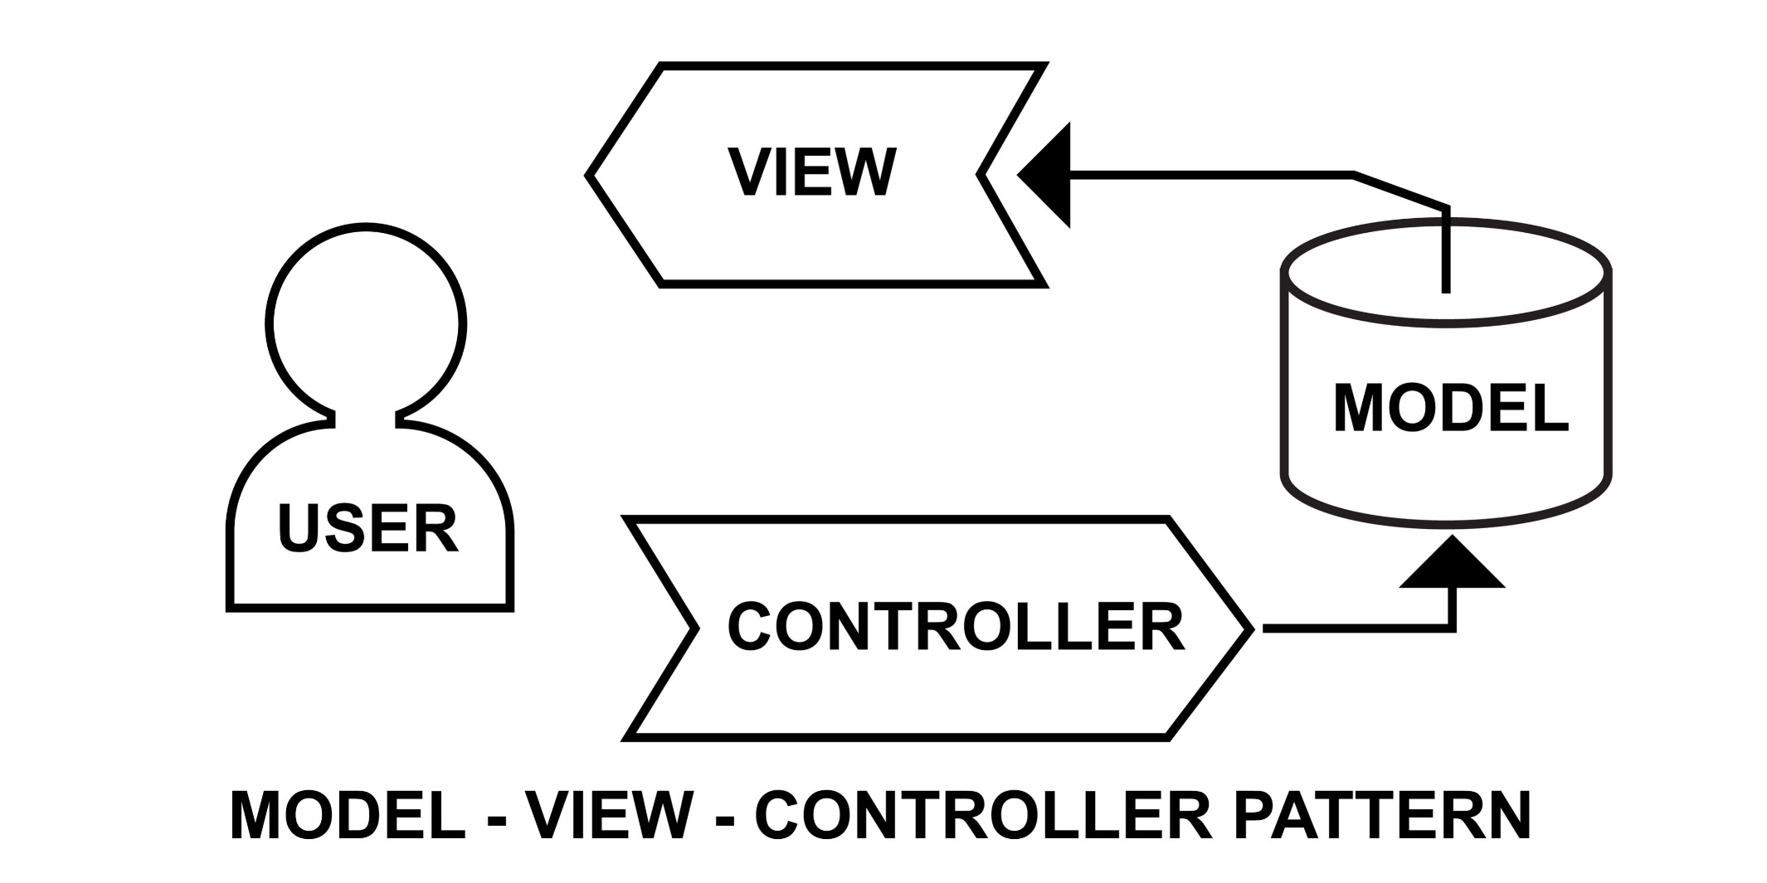
Licensed by Google
Web MVC: In modern web development, these roles are often fulfilled by specific tools:
- Model: A state management store like Redux or Vuex.
- View: UI components built with frameworks like React or Vue.
- Controller: Functions, hooks, or event handlers that connect the View to the Model.
Example: In an e-commerce app, the Model is the list of products in the shopping cart. The View is the cart page UI. The Controller is the addToCart function that updates the Model and triggers a re-render of the View.
Interview Language: "MVC separates our application into three core layers: Model, View, and Controller. This helps manage complexity by isolating data from the UI. A common pitfall is the 'fat controller,' where the controller becomes a monolith of logic."

MVP (Model-View-Presenter)
MVP is a variation of MVC where the Presenter handles all the business logic, making the View a passive, dumb UI layer. The Presenter holds a reference to both the View and the Model and orchestrates all interactions.
Explanation: The key difference from MVC is that the View has no knowledge of the Model. It only communicates with the Presenter, which makes the View easy to test in isolation.
Example: A user clicks a button in the View. The View simply notifies the Presenter. The Presenter then fetches data from the Model, updates it, and explicitly tells the View to display the new information.
Interview Language: "MVP is an evolution of MVC that enhances testability by making the View a passive layer. All logic is in the Presenter, which makes it easier to write unit tests for the application's core behavior."

MVVM (Model-View-ViewModel)
MVVM introduces the ViewModel layer for UI-related logic and state. It uses two-way data binding to automatically synchronize data between the View and the ViewModel.
Explanation: The View and ViewModel are connected through data binding. When a user interacts with the View (e.g., typing in a text field), the ViewModel is automatically updated. Conversely, when the ViewModel's state changes, the View updates itself without the need for manual intervention. This is ideal for frameworks with built-in data binding like Vue.js.
Example: In a user profile form, the input fields are directly bound to properties in the ViewModel. When the user types, the ViewModel's state updates automatically. When the user clicks "Save," the ViewModel handles the API call to update the Model.
Interview Language: "MVVM uses a ViewModel to manage UI state, and its core benefit is two-way data binding. This simplifies complex UI interactions by automatically keeping the View and its underlying data synchronized, which is great for frameworks like Vue or Angular."

Advanced Patterns
These patterns offer more structured and scalable solutions for large and complex applications.
Hierarchical MVC (HMVC)
HMVC extends MVC by breaking down a large application into a tree of independent MVC triads. Each module is a self-contained MVC unit that can also act as a View for a parent Controller.
Explanation: This pattern is great for modularity. A page can be composed of multiple HMVC modules. For example, a dashboard page could have a UserWidget module (its own MVC) and a NotificationsWidget module (another MVC), which are both managed by the main DashboardController.
Interview Language: "HMVC is a powerful way to scale an MVC application by creating independent MVC modules. It's great for large applications because it enhances modularity and reuse, preventing a single controller from becoming too large."

MVVMC (Model-View-ViewModel-Coordinator)
MVVMC extends MVVM with a Coordinator layer specifically for managing application flow and navigation.
Explanation: In this pattern, the ViewModel no longer handles navigation logic. Instead, it informs the Coordinator that a navigation event has occurred (e.g., "The user clicked the 'Go to Profile' button"). The Coordinator then decides which View to present, decoupling the navigation from the UI components.
Interview Language: "MVVMC adds a Coordinator layer to manage navigation. This is a best practice for keeping our ViewModels clean and focused on UI logic, making the application's flow and state transitions much more explicit and testable."

VIPER (View-Interactor-Presenter-Entity-Router)
VIPER is a rigid, highly structured pattern with each component having a single, clear responsibility. It's popular in mobile development for building highly testable and maintainable applications.
Explanation:
- View: The passive UI.
- Presenter: Prepares data for the View and receives user input.
- Interactor: Contains the core business logic.
- Entity: The plain data objects used by the Interactor.
- Router: Manages all navigation between modules.
Interview Language: "VIPER is a highly structured pattern that enforces a strong separation of concerns with five distinct components. It's excellent for building complex and testable applications by ensuring each part has a single responsibility, which makes the codebase easier to maintain over time."

Modern Architectural Styles
These modern styles focus on organizing code around business domains and features, rather than technical details.
Clean Architecture
Clean Architecture organizes software into concentric layers with dependencies pointing inward. The core idea is to make your business logic independent of frameworks, databases, and the UI.
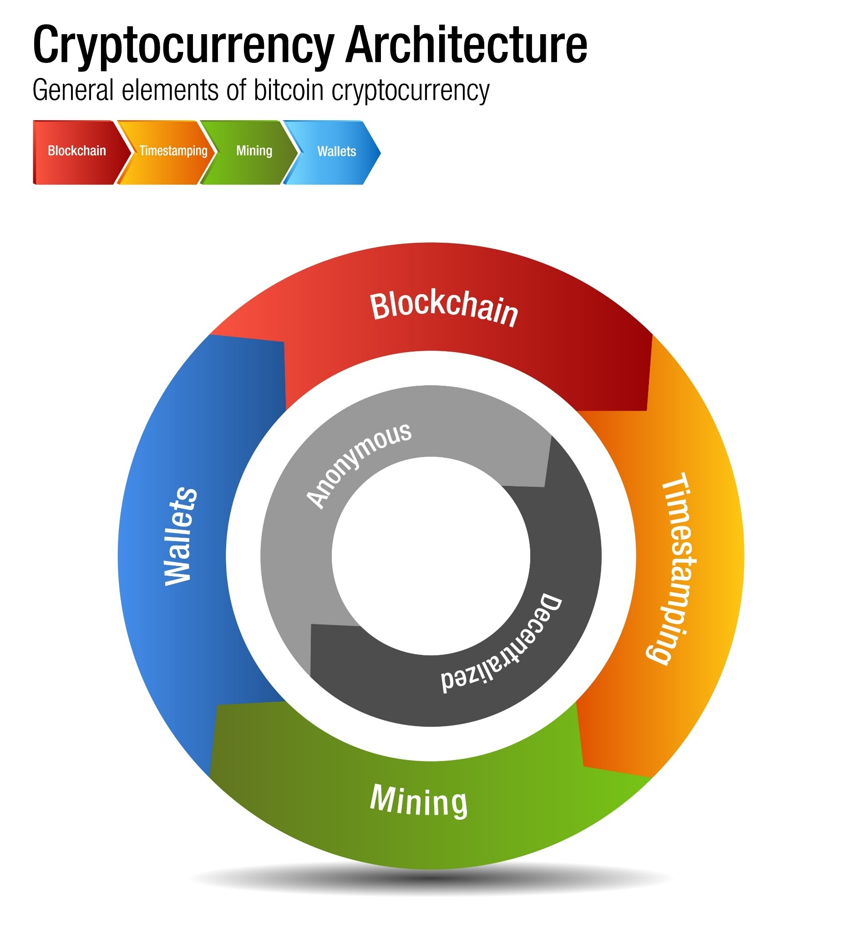
Licensed by Google
Explanation: The innermost layer is your domain logic. The outer layers are adapters that connect the core to external dependencies. This ensures that you can swap out the database or the UI framework without changing your core business rules.
Interview Language: "Clean Architecture is about framework independence. We structure our code to isolate our core business logic from the UI and external services, which makes the application highly adaptable and easier to maintain in the long run."

Hexagonal Architecture (Ports and Adapters)
Hexagonal Architecture separates the core application logic from external services and the UI by defining "ports" (interfaces) that the core uses to interact with the outside world.
Explanation: External components like a UI or a database are called "adapters." They implement the interfaces defined by the ports. This creates a clean boundary and allows you to easily swap out adapters without affecting the core business logic.
Interview Language: "Hexagonal Architecture, or Ports and Adapters, creates a clear boundary between the core business logic and external dependencies. This makes the application highly modular, as we can easily swap out different databases or UIs without changing the core."

Screaming Architecture
Screaming Architecture is a philosophy where a project's structure should be organized around business domains and features, not technical concerns. The file and folder names should "scream" what the application does.
Explanation: Instead of folders like controllers, services, and components, you would have folders named User, Product, and Order. Each folder would contain all the necessary files for that feature, regardless of their technical function.
Interview Language: "Screaming Architecture is a philosophy for organizing a codebase around business domains. Our project structure should immediately tell a new developer what the application does, making it intuitive and self-documenting."

Vertical Slices
Vertical Slices is a feature-based approach where each "slice" is a self-contained, end-to-end feature. Each slice contains its own logic, data access, and UI components.
Explanation: This is a very practical implementation of Screaming Architecture. Instead of having layers for the entire application, you have a separate, end-to-end slice for each feature. This enhances modularity and allows large teams to work on different features without creating conflicts.
Interview Language: "We use a vertical slices architecture to organize our codebase around individual features. This makes our application very modular and scalable, as each feature is a self-contained unit that can be developed and deployed independently."

UI Design Concepts
Good UI design goes beyond aesthetics, focusing on performance, accessibility, and security. Understanding these concepts is crucial for building robust and user-friendly applications.

1. HTTP/1.1 vs. HTTP/2
These are versions of the Hypertext Transfer Protocol, which governs communication between a browser and a server.
- HTTP/1.1: Sends one request at a time over a single TCP connection. To load a page with many resources (images, scripts, CSS), the browser must open multiple connections, which can be slow and inefficient.
- HTTP/2: A major revision that allows for multiplexing, meaning it can send multiple requests and responses concurrently over a single TCP connection. It also uses header compression, making communication faster.
Example:
- HTTP/1.1: A browser requests five images. It opens five separate connections to the server, one for each image.
- HTTP/2: A browser requests five images. It sends all five requests at once over a single connection, and the server can send back the images as they're ready.
Interview Language: "HTTP/2 is a significant improvement over HTTP/1.1 because it supports multiplexing, allowing us to load all our page resources over a single connection, which dramatically reduces latency and improves load times."

2. WebSocket vs. Webhook
These are mechanisms for real-time communication between a client and a server.
- WebSocket: A full-duplex protocol that creates a persistent, two-way communication channel between the client and server. The connection remains open, allowing either party to send data at any time without the other having to request it first.
- Webhook: A user-defined HTTP callback. Instead of a client constantly asking for updates, the server sends a request (the webhook) to a pre-defined URL when an event occurs. The client must expose a public endpoint to receive these requests.
Example:
- WebSocket: A live chat application uses a WebSocket to instantly send and receive messages between users. When a message is sent, it's pushed immediately to all connected clients.
- Webhook: A payment service notifies your application that a payment has been completed. Your server has a specific URL (/payment-webhook) that the payment service calls when the transaction is finished.
Interview Language: "We'd use a WebSocket for real-time, bidirectional communication, like a chat app or live data feed. A webhook is for event-driven, one-way communication from a server to our application, like receiving a payment notification."

3. Polling/Long Polling/REST API vs. GraphQL
These are different ways for a client to retrieve data from a server.
- Polling: The client repeatedly sends requests to the server at fixed intervals to check for new data. This is inefficient as most requests will return no new information.
- Long Polling: The client sends a request, and the server holds it open until new data is available or a timeout occurs. Once new data is sent, the connection closes, and the client immediately sends another request. This is more efficient than regular polling.
- REST API: A client retrieves data by making standard HTTP requests (GET, POST, PUT, DELETE) to specific URLs. The server determines the data to send based on the URL.
- GraphQL: A query language for APIs that allows the client to specify exactly what data it needs. The client sends a single request, and the server returns only the requested data, which prevents over-fetching and under-fetching.
Example:
- REST: To get user details and their posts, you might need to make two separate requests: GET /api/users/123 and GET /api/users/123/posts.
- GraphQL: You can get all the data you need in a single query: { user(id: "123") { name, posts { title } } }.
Interview Language: "We prefer GraphQL over REST because it gives the client more control. It allows us to fetch exactly the data we need in a single request, which reduces network overhead and improves performance on slow connections."

4. Server-Side Elements
UI design isn't just client-side. The server can render and send initial UI components to the client. This is a practice known as Server-Side Rendering (SSR).
Explanation: In SSR, the server processes the HTML and dynamic content and sends a fully rendered page to the browser. This results in a faster "First Contentful Paint" (FCP) because the user sees the content immediately, even before the JavaScript is fully loaded.
Interview Language: "We use Server-Side Rendering for our main pages to ensure a fast initial load and improve our SEO. By having the server send a fully rendered HTML page, we provide a better user experience and make it easier for search engines to crawl our site."

Rendering
Rendering is the process of generating the final visual output on the screen.
Tree Shaking
Tree shaking, also known as dead code elimination, is a technique used during the build process to remove unused code from the final bundle.
Explanation: When you import a library, you might only use a small fraction of its functions. Tree shaking analyzes your code and only includes the parts of the library that you actually use, resulting in a smaller final JavaScript file.
Example: You import a utility library with 100 functions, but only use debounce and throttle. A modern bundler like Webpack or Vite will use tree shaking to ensure that only the code for those two functions is included in your production bundle, rather than all 100 functions.
Interview Language: "We use tree shaking to optimize our bundles. It's a build-time optimization that removes dead code, ensuring our final JavaScript files are as small as possible, which directly improves load times."

Accessibility
Accessibility (a11y) is the practice of making your application usable by people with disabilities. It's a fundamental part of good UI design.
Proper Contrast
Proper contrast ensures that text is easily readable against its background. The Web Content Accessibility Guidelines (WCAG) specify minimum contrast ratios to meet accessibility standards.
Explanation: Low contrast can be difficult for people with low vision to read. Tools can be used to check if your color choices meet the required contrast ratio (e.g., 4.5:1 for normal text).
Example: Using light gray text on a white background has poor contrast. Using dark gray or black text on a white background has good contrast, making it much easier to read for all users.
Interview Language: "We prioritize proper color contrast to ensure our application is accessible. We follow WCAG guidelines to make sure that our text and UI elements are clearly visible against their backgrounds."
ARIA Roles
ARIA (Accessible Rich Internet Applications) roles are HTML attributes that provide semantic meaning to UI components for assistive technologies like screen readers.
Explanation: Standard HTML elements have built-in semantics, but custom UI components (like a modal or a custom dropdown) may not. ARIA roles and attributes can be used to describe the purpose and state of these components to a screen reader.
Example: A div element is semantically meaningless. By adding role="button", you tell a screen reader that this div should be treated as a button. Similarly, an attribute like aria-expanded="true" tells the screen reader that a collapsible section is currently open.
Interview Language: "We use ARIA roles to enhance accessibility, especially for custom components. It helps assistive technologies like screen readers understand the purpose and state of our UI elements, making our application navigable for users with visual impairments."

Security
Frontend security is about protecting the client from attacks and ensuring data integrity.
XSS (Cross-Site Scripting)
Cross-Site Scripting (XSS) is a type of security vulnerability that allows attackers to inject malicious scripts into a web page viewed by other users.
Explanation: An XSS attack occurs when an application takes user input and renders it directly in the HTML without proper sanitation. The injected script can then steal cookies, manipulate the DOM, or redirect the user to a malicious site.
Example: A user leaves a comment containing <script>alert('xss');</script> on a blog. If the blog doesn't sanitize the input, other users who view the comment will have that script executed in their browsers. The attacker could replace alert with a script to steal the user's session cookies.
Interview Language: "We prevent XSS attacks by sanitizing all user input before rendering it. We use libraries and frameworks with built-in protections to ensure that any malicious scripts are neutralized."
Rate Limiting
Rate limiting is a security measure that controls the number of requests a user can make to a server within a given time.
Explanation: While rate limiting is primarily a backend security practice, it is crucial for protecting your backend APIs from brute-force attacks or resource exhaustion. The UI should be designed to handle the 429 Too Many Requests error gracefully.
Example: An attacker tries to guess a user's password by making 100 login attempts per second. Rate limiting will detect this behavior and block subsequent requests after a certain threshold (e.g., 5 attempts per minute), preventing the attack.
Interview Language: "We implement rate limiting on our backend to protect against brute-force attacks and abuse. On the frontend, we handle the 429 status code gracefully and provide a clear message to the user."
CORS
Cross-Origin Resource Sharing (CORS) is a security feature that controls which origins (domains) are allowed to make requests to your API.
Explanation: CORS prevents a malicious website from making unauthorized requests to your API on behalf of a user. The browser enforces this policy by checking the Access-Control-Allow-Origin header in the server's response.
Example: An attacker's website, malicious.com, tries to make an API request to your application, myapp.com, from a user's browser. If your server doesn't explicitly allow malicious.com in its CORS headers, the browser will block the request.
Interview Language: "CORS is a browser security mechanism that we use to protect our APIs from cross-origin requests. We configure our server's CORS policy to explicitly allow only trusted origins to access our API."

Data Model & API Model
This section of a frontend system design interview focuses on how data is structured and how the client communicates with the server.
Data Model
The data model defines the structure and relationships of the data used by the application on the client-side. You'll need to think about the objects your application will handle, like users, feed items, or products, and define their properties and data types. A good data model should be flexible enough to handle different types of content, such as server-driven UI elements and rich text.
Example: For a social media feed, you might define data models for a User and a Post.
- User Model:
User {
id: string,
username: string,
profilePictureUrl: string
}
- Post Model:
Post {
id: string,
author: User, // A reference to the User model
content: string,
likes: number,
comments: Comment[] // A list of Comment models
}
This structure allows the frontend to easily understand and render the data it receives from the backend.
Interview Language: "I'd start by defining our client-side data models for key entities like User and Post. This ensures a clear structure for our application's state. When designing these, I consider the potential for server-driven UI, where the backend can send a template or component type, and rich text content, which would require a specific format like markdown or a defined content object."
API Model
The API model defines the communication protocol and structure for how the client requests and receives data from the server. The choice of API style heavily impacts performance and flexibility.
- HTTP/1.1 vs. HTTP/2: HTTP/2 is a major improvement, offering multiplexing to send multiple requests over a single connection, which is more efficient than HTTP/1.1's one-request-at-a-time model.
- Polling/Long Polling: Involves the client repeatedly asking the server for new data. Long polling is more efficient as the server holds the request until new data is available.
- WebSockets/Server-Sent Events (SSE): These enable real-time communication. WebSockets provide a bidirectional channel, while SSE offers a one-way channel from server to client, both of which are ideal for live updates like a news feed.
- REST vs. GraphQL: REST uses multiple endpoints for different resources. GraphQL allows the client to request specific data fields from a single endpoint, preventing over-fetching or under-fetching. For a news feed where clients might need different data for different views (e.g., a short summary vs. the full post), GraphQL is often the recommended choice due to its flexibility.
Interview Language: "For our API, I'd propose using GraphQL. It gives the frontend team the flexibility to fetch exactly the data they need, which is great for a dynamic news feed where different components require different data. We would use HTTP/2 as the underlying protocol for its multiplexing capabilities to further optimize network performance."

4. Optimizations and Performance
This is a critical part of a frontend system design, focusing on making the application fast and responsive.
Network Performance
These optimizations focus on reducing the amount of data transferred and the number of requests made over the network.
- HTTP/2: Using HTTP/2's multiplexing and header compression reduces latency.
- Caching: Storing data and assets locally on the client to avoid re-fetching them. This can be done at the CDN level or in the browser cache.
- Image Optimization: Compressing images and using modern formats like WebP to reduce file size.
- Request Batching: Grouping multiple API calls into a single request to reduce network overhead.
- Bundle Splitting: Breaking the application's JavaScript into smaller chunks that are loaded only when needed.
Example: A large e-commerce site uses a CDN to serve images from the closest server to the user. It also uses bundle splitting to load the checkout page's JavaScript only when the user navigates to it, rather than on the initial page load.
Interview Language: "I'd prioritize network performance by ensuring we're using HTTP/2 and a CDN. For the application code, I'd implement bundle splitting to only load the necessary code for the current page, and use image optimization to reduce asset size, which are all key for improving load times."
Rendering Performance
These optimizations focus on how quickly the browser can paint the UI and handle user interactions.
- Server-Side Rendering (SSR): Rendering the initial HTML on the server provides a fast "First Contentful Paint" (FCP), which is great for SEO and perceived performance.
- Resource Preloading: Using browser features like <link rel="preload"> to fetch critical resources before they are needed.
- Tree Shaking: A build-time optimization that removes unused code from the final bundle, resulting in a smaller file size.
- Virtualization: For long lists (e.g., a news feed), only rendering the visible items and a small buffer. As the user scrolls, new items are rendered and old ones are removed from the DOM, saving memory and improving performance.
Interview Language: "To improve rendering performance, I'd consider Server-Side Rendering (SSR) for our initial page load to improve FCP. For long feeds, I would definitely recommend list virtualization to ensure we're not rendering thousands of DOM nodes at once, which can dramatically slow down the application. I'd also use tree shaking to minimize our bundle size."

5. Accessibility & Security
These are non-functional requirements that are critical for a robust and ethical application.
Accessibility
Accessibility (a11y) ensures that a website is usable by people with disabilities.
- ARIA Roles: Accessible Rich Internet Applications (ARIA) roles provide semantic meaning to HTML elements for assistive technologies like screen readers. For custom components, ARIA roles are essential to describe their purpose and state.
Example: A custom button element made from a div can be made accessible by adding role="button" and tabindex="0".
Interview Language: "Accessibility is a non-negotiable part of our design. We'd use ARIA roles to ensure our custom UI components are properly understood by screen readers, and we'd check for proper color contrast to make our application usable for everyone."
Security
Frontend security protects the client from attacks and prevents data breaches.
- CORS (Cross-Origin Resource Sharing): A browser security feature that prevents a malicious website from making unauthorized requests to your API.
- Rate Limiting: Protects the backend from brute-force attacks by limiting the number of requests a user can make in a given time.
- Sanitizing User Input (XSS): To prevent Cross-Site Scripting (XSS) attacks, all user-generated content must be sanitized before being rendered to ensure no malicious scripts can be injected.
Interview Language: "Security is paramount. We'd enforce a strong CORS policy on our backend to prevent cross-origin attacks. On the frontend, we'd use a robust library to sanitize all user input to prevent XSS attacks, and our backend would have rate limiting to prevent abuse and brute-force attacks."

API Models & Communication Styles
This section covers different ways a client can communicate with a server. The choice of API model significantly impacts an application's performance, real-time capabilities, and flexibility.

HTTP/1.1 vs. HTTP/2
HTTP is the foundational protocol for communication on the web.
- HTTP/1.1: This is the older version where the browser sends one request at a time over a single TCP connection. To fetch multiple resources (like images, CSS, and JavaScript files), the browser has to open several connections, which can be slow and inefficient. This can lead to a "head-of-line blocking" issue, where a slow response holds up subsequent requests.
- HTTP/2: A significant improvement that allows for multiplexing. This means a browser can send multiple requests concurrently over a single TCP connection. It also uses header compression, further reducing overhead. This makes loading pages with many resources much faster.
Example: To load a page with 10 images:
- HTTP/1.1 might open 6 separate connections and download the images one after the other.
- HTTP/2 would download all 10 images over a single connection at the same time.
Interview Language: "We use HTTP/2 over HTTP/1.1 because of its multiplexing capabilities. This allows us to send multiple requests and receive responses concurrently over a single connection, which dramatically improves our application's performance and reduces latency."

Polling
Polling is a simple communication technique where the client repeatedly sends requests to the server at fixed intervals to check for new data.
Explanation: The client asks, "Any new data?" and the server responds with either "No" or the new data. This process repeats constantly. It's often inefficient because most requests will return no new information, wasting network resources and server processing power.
Example: A client-side dashboard refreshes every 5 seconds to check for new data from the server. For a live news feed, this could mean many unnecessary requests.
Interview Language: "We use polling for scenarios where updates are not time-sensitive, but it's generally inefficient. It involves the client making repeated requests to the server, which can lead to high network traffic and resource usage."

GraphQL
GraphQL is a query language for APIs that gives the client control over the data it needs. Instead of the server deciding what data to send, the client specifies exactly what data fields it wants.
Explanation: A client sends a single, flexible request to a single endpoint. The server responds with only the requested data, which solves the common problems of over-fetching (getting more data than you need) and under-fetching (needing to make multiple requests to get all the data).
Example:
- REST API: To get a user's name and their posts, you might need two requests: GET /users/1 and GET /users/1/posts.
- GraphQL: You can make a single request that specifies exactly what you need:
GraphQL
query {
user(id: "1") {
name
posts {
title
}
}
}
This returns a single JSON object with only the name and post titles.
Interview Language: "For our news feed, I'd recommend GraphQL. It provides a flexible API that allows the client to request only the data it needs, which is crucial for reducing network overhead and optimizing performance, especially on mobile devices."

WebSockets
WebSockets provide a persistent, full-duplex communication channel between a client and a server. Once the connection is established, either the client or the server can send data at any time without having to send a new request each time.
Explanation: The WebSocket connection is initiated with a standard HTTP handshake, but it then "upgrades" to a persistent, two-way connection. This is the ideal choice for applications that require low-latency, real-time communication.
Example: A live chat application uses a WebSocket. When a user sends a message, it is immediately pushed to all other connected clients without them having to make a new request.
Interview Language: "We would use WebSockets for features that require true real-time, bidirectional communication, such as a live chat or collaborative editing tool. This protocol keeps an open connection, allowing the server to push updates to the client instantly."

Server-Sent Events (SSE)
Server-Sent Events (SSE) provide a one-way, real-time communication channel from the server to the client.
Explanation: Like WebSockets, SSE maintains a persistent connection, but it is unidirectional. The client subscribes to an endpoint, and the server can push a continuous stream of text-based event data to it. SSE is simpler than WebSockets and is great for scenarios where the client only needs to receive updates, but doesn't need to send data back in real-time.
Example: A stock ticker or a news feed that streams live updates. The server pushes new stock prices or headlines to the client as they become available.
Interview Language: "Server-Sent Events are a great choice for one-way, real-time data streaming, like a live news feed or a notification system. It's simpler than WebSockets and works well when the client just needs to receive updates from the server."

Long-Polling
Long-polling is a technique used to enable real-time updates from a server to a client. Instead of the client constantly asking the server for updates (polling), it sends a single request that the server holds open until new data is available or a timeout occurs. Once the server sends new data, the connection closes, and the client immediately sends a new request to start the process over.
Explanation: This method is much more efficient than traditional polling because it eliminates the need for numerous requests that often return no new information. The client only receives a response when there's something to report. This reduces network traffic and server load, making it a good solution for scenarios where real-time updates are needed but a full-duplex connection like a WebSocket isn't necessary.
Example: Imagine a chat application.
- A user's browser sends a long-polling request to the server, asking for new messages.
- The server receives the request but doesn't respond immediately. It waits for another user to send a message.
- When a new message arrives, the server immediately sends the message back to the first user's browser, closing the connection.
- The browser receives the new message and instantly sends a new long-polling request, starting the cycle again.
Interview Language: "Long-polling is a technique we use for real-time updates. The client sends a request to the server, and the server holds the connection open until there's new data. This is more efficient than regular polling because it avoids unnecessary requests and reduces the load on both the client and the server."

Module Federation
Module Federation is a feature of Webpack that allows developers to share code between different applications, often called "micro-frontends," at runtime. It enables a host application to dynamically load code from a remote application.
Explanation: In a traditional micro-frontend setup, you might build a separate JavaScript bundle for each application. Module Federation simplifies this by allowing one application to serve as a host and dynamically load a piece of code (a "remote" module) from another application. The remote application exposes its code as a module, and the host consumes it. This means different teams can develop, build, and deploy their code independently while sharing common components.
Example: An e-commerce website has a "product details" page that needs a ProductCard component. Instead of bundling the ProductCard with the main application, a separate "products" micro-frontend exposes the ProductCard as a federated module. The "product details" micro-frontend (the host) then loads and renders the ProductCard from the remote "products" application at runtime.
Interview Language: "Module Federation is a powerful Webpack feature for building micro-frontends. It allows us to dynamically share code between different applications at runtime. This is crucial for large teams because it enables them to develop and deploy their features independently while still sharing common components, which improves our development velocity."

Concept of BFF (Backend for Frontend)
BFF (Backend for Frontend) is an architectural pattern where a dedicated backend service is created specifically to serve a particular frontend application. Instead of all frontends consuming a single, monolithic backend API, each frontend has its own tailored BFF.
Explanation: In a microservices architecture, a single frontend might need to make calls to multiple microservices to gather all the data for a page. This can lead to increased network latency and complexity on the frontend. The BFF solves this by acting as an intermediary. It aggregates data from multiple microservices and provides a single, optimized response to its corresponding frontend. This simplifies the frontend code and improves performance.
Example: A mobile app needs to display a user's profile, which requires data from a user-service, a profile-service, and an orders-service.
- Without BFF: The mobile app would have to make three separate network calls to get all the data.
- With BFF: A dedicated mobile BFF would make the three calls to the microservices, aggregate the data, and send a single, optimized response to the mobile app.
Interview Language: "A BFF is a great pattern for simplifying our frontend applications. It's a dedicated backend service that aggregates data from multiple microservices and provides a single, tailored API for a specific frontend. This reduces network calls, optimizes data payloads, and ultimately makes our frontend code simpler and more performant."

What is MFE (Micro-frontend)?
A Micro-frontend (MFE) is an architectural style where a web application is composed of multiple independent, smaller applications that can be developed, tested, and deployed autonomously by different teams.
This approach is an analogy to the microservices concept, but applied to the frontend. Instead of building a single, monolithic frontend application, you break it down into feature-specific components that can be managed by dedicated teams.

Key Concepts
- Autonomy: Each MFE is a separate, self-contained application with its own codebase, dependencies, and deployment pipeline. This means teams don't have to coordinate their releases, leading to faster development cycles.
- Technology Agnostic: Different MFEs can be built using different technologies. For example, a dashboard MFE might be built with React, while a checkout MFE uses Vue. This allows teams to choose the best tool for the job.
- Composition: A host application or shell is responsible for rendering and composing the different MFEs into a single, cohesive user interface. This can be done at various points, such as build time, server-side, or client-side.

MFE Example
Imagine a large e-commerce website. Instead of one large frontend, it's broken down into several MFEs:
- Header MFE: Managed by a team responsible for the site's navigation and search bar.
- Product List MFE: Developed by a team that owns the product catalog and filtering logic.
- Shopping Cart MFE: Maintained by a team that handles the cart functionality and promotions.
- Checkout MFE: A separate MFE for the payment and delivery process.
When a user visits the homepage, the host application loads and displays the Header MFE, the Product List MFE, and a mini-cart component from the Shopping Cart MFE, all working together seamlessly.

Interview Language
"Micro-frontends (MFEs) are an architectural pattern for breaking down a monolithic frontend into independent, feature-specific applications. The main benefit is that it allows different teams to work on, test, and deploy their code autonomously."
"We use MFEs to scale our development efforts. Instead of a single large codebase, we have smaller, more manageable applications. This allows us to use different technologies for different parts of the application and reduces coordination overhead between teams."
"A key challenge with MFEs is managing the composition of these separate applications and ensuring a consistent user experience across all of them, but this is a trade-off for the increased agility and scalability we gain."

What is GraphQL?
GraphQL is a query language for APIs and a runtime for fulfilling those queries with your existing data. It gives the client the power to request exactly the data it needs, nothing more and nothing less. This is different from a traditional REST API, where the server determines the data structure for each endpoint.

GraphQL vs. REST
Feature | GraphQL | REST
Data Fetching | Client-driven: Clients request specific fields. | Server-driven: The server returns a fixed data structure for each endpoint.
Endpoints | Typically a single endpoint (e.g., /graphql). | Multiple endpoints (e.g., /users, /users/123, /posts).
Efficiency | Highly efficient; no over-fetching (getting extra data) or under-fetching (needing multiple requests). | Can be inefficient; often leads to over-fetching or requires multiple round trips.
Real-time | Has built-in support for real-time data with Subscriptions. | Requires separate technologies like WebSockets for real-time.
Export to Sheets
Example: Imagine an app needs a user's name and their first 5 post titles.
- REST: You might need to call /users/123 to get the user's name (and a lot of other data you don't need) and then /users/123/posts?limit=5 to get the post titles.
- GraphQL: You can make a single request to the /graphql endpoint:
GraphQL
query {
user(id: "123") {
name
posts(first: 5) {
title
}
}
}
The server responds with a single JSON object containing only the requested fields.
Interview Language: "GraphQL is a client-driven API query language, which means the client dictates what data it needs. This is a key difference from REST, where the server defines the data structure for each endpoint. Using GraphQL prevents over-fetching and under-fetching, making our API calls more efficient, especially on mobile networks. It also provides a great developer experience by allowing us to get all the data we need in a single request."

What is gRPC?
gRPC (gRPC Remote Procedure Calls) is a high-performance, open-source framework developed by Google for building APIs. It uses Protocol Buffers to define a service and the messages that are exchanged. gRPC is designed for low-latency, high-throughput communication between microservices.
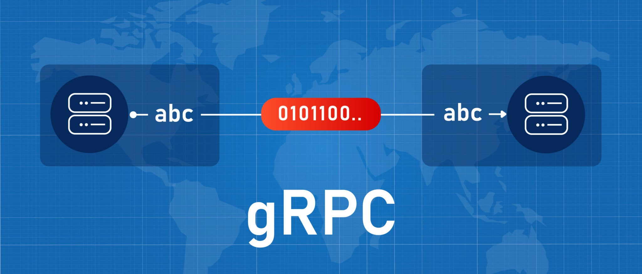
Licensed by Google

gRPC vs. REST
Feature | gRPC | REST
Protocol | HTTP/2, which enables features like multiplexing. | Primarily HTTP/1.1, though it can use HTTP/2.
Payload | Protocol Buffers, a highly efficient binary format. | Typically JSON, which is human-readable but less performant.
Efficiency | Extremely high performance due to binary payload and HTTP/2. | Good performance, but generally slower than gRPC.
Code Generation | Automatically generates client and server code in various languages. | Requires manual implementation of client and server logic.
Export to Sheets
Example: In a microservices environment, a Payment service needs to communicate with an Order service.
- REST: The Payment service would make an HTTP request to the Order service's REST endpoint (e.g., POST /orders/123/process-payment). The data would be a JSON payload.
- gRPC: The service contract is defined in a .proto file. The Payment service would then call a method like Order.ProcessPayment(request) as if it were a local function call. The request data would be a compact, binary Protocol Buffer.
Interview Language: "gRPC is a high-performance framework for building APIs, primarily used for service-to-service communication. It's built on HTTP/2 and uses a binary format called Protocol Buffers, which makes it much faster and more efficient than REST APIs that use JSON over HTTP/1.1. gRPC also simplifies development by automatically generating client and server code from our service definitions."

What is Domain-Driven Architecture?
Domain-Driven Architecture (DDA) is a software design approach that centers on a "domain model," which represents the business logic and behavior of an application. The goal is to build a system that reflects the real-world business concepts and terminology, making it easier for developers to understand and communicate with business experts.
The core principle is to align the software design with the specific business domain. The architecture is structured around modules that represent different parts of the business. This approach is often used in complex systems to manage complexity and ensure the software accurately models the business.
Interview Language: "Domain-driven architecture is a design philosophy where we structure our codebase around the business domain, not the technology. This means our code and models directly reflect the real-world concepts and language of the business. It helps us build more robust and maintainable applications, especially in complex systems, by ensuring a clear alignment between the software and the business requirements."

Deep Links vs. Backlinks
Feature | Deep Link | Backlink
Purpose | To open a specific page or state within a mobile app. | A link from one website to another, used for SEO and referral traffic.
Mechanism | A URI (Uniform Resource Identifier) scheme that directs the user to a specific location in an app. | A standard HTML hyperlink (<a> tag) that connects two websites.
Target | A specific screen or content inside a mobile application. | Another website or web page.
Export to Sheets
Example:
- Deep Link: A user receives an email with a link that, when clicked on a mobile device, opens the Amazon app directly to a specific product page. The link might look like amazon://product/12345.
- Backlink: A blog post on "top tech gadgets" includes a link to a product page on Amazon. This link helps to drive traffic to Amazon and improves Amazon's search ranking.
Interview Language: "A deep link is a URI that opens a specific piece of content within a mobile app, whereas a backlink is a standard hyperlink from one website to another. We use deep links for a seamless user experience, such as directing users from a marketing email directly to a product page in our app. Backlinks, on the other hand, are a core part of SEO and are used to drive traffic and build authority between websites."

Pagination with Offset vs. Keyset vs. Cursor
Pagination is a common technique to handle large datasets by splitting them into smaller pages. The three main methods differ in how they retrieve the "next" page.
- Offset-based Pagination: This is the most common method, using LIMIT and OFFSET clauses in a database query. It works by skipping a certain number of rows and then fetching the next set.
  - Pros: Simple to implement.
  - Cons: Can be slow on large tables because the database has to scan through all the skipped rows. It's also susceptible to inconsistencies if new data is added or removed while a user is paginating.
- Keyset-based Pagination: This method uses the value of the last item from the previous page to determine where to start the next query. It's also known as "seek" or "stable" pagination.
  - Pros: Much more efficient on large tables than offset, as it avoids skipping rows. It's also more stable because it's not affected by insertions or deletions in previous pages.
  - Cons: Requires a unique, ordered key (like an ID or a timestamp) and is less flexible for jumping to a specific page.
- Cursor-based Pagination: A more generalized version of keyset pagination. It uses an opaque value (the "cursor") to represent the position of the last item from the previous page.
  - Pros: Highly efficient, stable, and often used in modern APIs like GraphQL. The cursor can be encrypted to prevent tampering.
  - Cons: More complex to implement than offset pagination.
Interview Language: "I'd choose a keyset or cursor-based pagination approach over offset-based for large datasets. While offset is easy to implement, it becomes inefficient and unreliable on huge tables because the database has to scan all the skipped rows. Keyset pagination is much more performant and stable as it queries based on the last item's ID, avoiding these issues. Cursor-based pagination is a more robust version of this, and it's what we see in many modern APIs."

Debouncing and Throttling
Both debouncing and throttling are performance optimization techniques used to limit the rate at which a function is executed, but they work in different ways.
- Debouncing: Delays the execution of a function until after a specified period of inactivity. This is useful for events that can fire rapidly, such as a user typing in a search bar. The function will only run once the user has stopped typing for a certain amount of time.
- Throttling: Limits the execution of a function to once every specified period of time. This is useful for events that are triggered frequently and continuously, like scrolling or resizing a window. The function will fire at a regular interval, regardless of how often the event is actually triggered.
Example:
- Debouncing: A user types in a search bar. Instead of sending an API request on every keystroke, a debounced function waits for a 300ms pause in typing before sending the request.
- Throttling: A user scrolls down a page. A throttled function fires every 200ms to update the scroll position, even if the user scrolls much faster.
Interview Language: "Debouncing and throttling are key performance optimizations. Debouncing is used to group rapid events into a single execution after a period of inactivity, which is perfect for search input fields. Throttling is used to ensure a function is only executed at a consistent interval, which is ideal for events like scrolling or window resizing. The key difference is that debouncing waits for a pause, while throttling fires at a fixed rate."

SSE API for Real-Time Updates
SSE (Server-Sent Events) is a server-push technology that enables a client to receive a stream of updates from a server over a single, long-lived HTTP connection. It's a simple, efficient way for a server to send real-time data to a client.
Explanation: Unlike a WebSocket, which is a full-duplex, bidirectional protocol, SSE is unidirectional—data flows only from the server to the client. The connection is a standard HTTP request, but the server keeps the connection open and sends a series of text-based messages. The browser automatically handles reconnecting if the connection drops. This simplicity makes it a great choice for scenarios like live news feeds or stock tickers where the client only needs to receive updates.
Example: A live stock market app uses SSE to show real-time price changes.
- The client sends a GET request to the server's SSE endpoint (e.g., /stock-stream).
- The server keeps the connection open.
- When a stock's price changes, the server sends a message to the client in a specific format (data: {"symbol": "APPL", "price": 180.50}\n\n).
- The browser's EventSource API handles receiving the message and triggers a JavaScript event, which then updates the UI.
Interview Language: "SSE is a server-push API for real-time, one-way updates. It's ideal for a live news feed or notification system because it's a lightweight protocol that allows the server to stream events to the client over a single HTTP connection. It's simpler to implement than WebSockets and has built-in features like automatic reconnection."

Infinite Scroll
Infinite scroll is a user interface design pattern where content is loaded continuously as a user scrolls down a page, eliminating the need for traditional pagination (e.g., "Page 1," "Page 2").
Explanation: Instead of having discrete pages, the application waits until the user reaches the bottom of the current content. At that point, a trigger is fired to fetch the next batch of content from the server and append it to the current list. This creates a seemingly endless feed, which can be great for engagement and user experience on social media and content-heavy sites.
Example: A user is Browse a social media feed.
- The initial page loads with 10 posts.
- As the user scrolls down, the application detects that they are approaching the bottom of the page.
- A function is triggered to fetch the next 10 posts from the API.
- The new posts are appended to the existing list, and a "loading" spinner is briefly shown while the data is fetched.
Interview Language: "Infinite scroll is a UI pattern where we load new content as the user scrolls, creating a continuous feed. It improves user engagement by removing the friction of clicking 'next page,' and it's particularly effective for applications like social media or e-commerce where users want to browse a large amount of content."

Pagination with Offset vs. Cursor
Pagination is the process of dividing a large dataset into smaller chunks, or pages. The main methods for this are offset-based and cursor-based.
- Offset-based Pagination: This is the most common method, using LIMIT and OFFSET in a database query. You specify how many items to return (LIMIT) and how many to skip (OFFSET). For example, to get the third page of 10 items, you would use LIMIT 10 OFFSET 20.
  - Pros: Simple to implement and understand. Allows users to jump to any page number.
  - Cons: Can be very inefficient on large datasets because the database has to scan all the skipped rows. It can also lead to inconsistent results if data is added or removed from the table while a user is paginating.
- Cursor-based Pagination: This method uses a unique, immutable value (the "cursor") from the last item on the previous page to determine the starting point for the next query. For example, the query would ask for the next 10 items after a specific id or timestamp.
  - Pros: Highly efficient and scalable, as the database doesn't need to scan skipped rows. It's also more robust and reliable because it’s not affected by changes to the dataset.
  - Cons: More complex to implement and doesn't allow users to "jump" to a specific page number, as the context of the previous page is required.
Interview Language: "I prefer cursor-based pagination for scalable applications over offset-based. While offset is easy, it's inefficient for large databases and can lead to inconsistent results. Cursor-based pagination uses the last item's ID as a pointer, which is much more performant and reliable, making it the better choice for production systems."

Design Patterns and Anti-Patterns
A design pattern is a reusable solution to a commonly occurring problem in software design. It's a template for how to solve a problem that has been proven to work well over time.
An anti-pattern is a commonly occurring but ineffective or counterproductive solution to a problem. It's a pattern that looks good on the surface but ultimately leads to negative consequences like code complexity, reduced performance, or maintenance issues.
Example:
- Design Pattern: Singleton. This pattern ensures that a class has only one instance and provides a single global point of access to it. It's useful for things like a database connection or a configuration object.
- Anti-Pattern: Singleton. While a Singleton can be useful, it can also be an anti-pattern if overused. It can introduce global state, which makes testing difficult and can lead to tight coupling in the application. Another anti-pattern is the "god object," a single class that knows too much and does too much, making it hard to maintain.
Interview Language: "A design pattern is a proven solution for a common software problem, like the Singleton or Observer pattern. An anti-pattern is the opposite—a common but flawed solution that leads to bad outcomes, like a 'god object' that has too many responsibilities. We use design patterns to build robust and maintainable software, and we recognize anti-patterns to avoid them."

Clean Architecture
Clean Architecture is a software design philosophy proposed by Robert C. Martin, also known as "Uncle Bob." It's a system for organizing code into concentric layers, with dependencies pointing inward. The core principle is to make the business logic independent of frameworks, databases, and the UI.
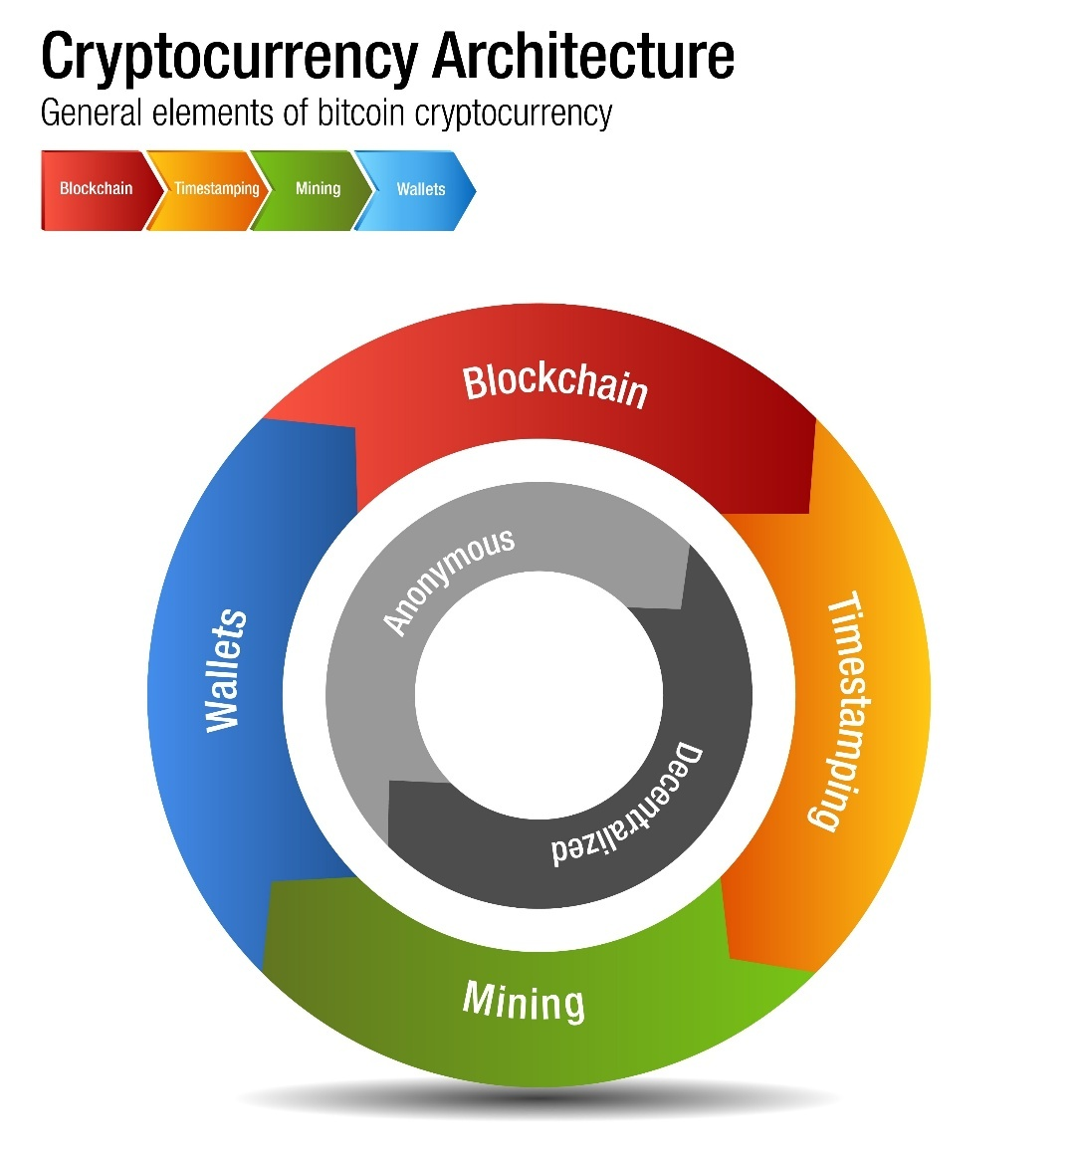
Licensed by Google
Explanation: The innermost layer contains the core business rules and is independent of all other layers. The outer layers are adapters that connect the core logic to things like the UI, a database, or external APIs. This separation ensures that the core application remains testable and can be easily adapted to new technologies without being rewritten.
Interview Language: "Clean Architecture was proposed by Robert Martin. Its main goal is to create a highly testable and maintainable system by separating the core business logic from external dependencies like the UI and databases. This architecture ensures that our most important code is independent of any frameworks, which makes our application highly adaptable and scalable."

The Composable Architecture (TCA)
The Composable Architecture (TCA) is a library for building applications in a consistent and predictable way, with a focus on testability and modularity. It was created for Swift, a programming language used for iOS and other Apple platforms.
Explanation: TCA is a state management pattern that uses three core concepts:
- State: The data your app needs to do its job.
- Actions: A way to describe every event that can happen in your app.
- Reducers: A function that takes the current state and an action and returns the new state.
The key benefit is that it makes your application's logic completely predictable and testable by separating the state, actions, and side effects. You can easily test every possible state transition without relying on the UI.
Interview Language: "The Composable Architecture (TCA) is a framework for building highly testable and modular applications, particularly in Swift. It uses a clear pattern of State, Actions, and Reducers to manage application state. This design makes it incredibly easy to test every single piece of business logic in isolation, which is a huge benefit for building reliable applications."

Data Handling in Android
Data handling on Android involves fetching data from various sources and storing it efficiently. It's a key part of building any mobile application.
1. Fetching Data
Mobile apps need to get data from a server. There are several ways to do this, each with its own use case.
- REST API: The most common way to fetch data. Your app sends an HTTP request (like a GET, POST, or PUT) to a server endpoint and receives a response, usually in JSON format. Libraries like Retrofit make this process simple.
  - Example: A news app sends a GET request to https://api.example.com/news/articles to get a list of the latest articles.
  - Interview Language: "We primarily use REST APIs for fetching data. It's a standard, flexible approach for getting and sending data from a backend server. We use a library like Retrofit to handle the network calls and serialize the JSON responses into our data models."
- WebSockets: This protocol provides a persistent, two-way communication channel between the client and server. Unlike a REST API, where the client has to request data, a server can push data to the client at any time. It's perfect for real-time updates.
  - Example: A chat app uses WebSockets to instantly send and receive messages between users without constant polling.
  - Interview Language: "For real-time features like chat or live notifications, we would use WebSockets. It maintains an open connection, allowing the server to push updates to the client instantly without us needing to poll the server for new information."
2. Caching and Storage
Once you have the data, you need a way to store it on the device for quick access or offline use.
- SQLite: A lightweight, relational database built directly into Android. It's great for storing structured data that needs to be queried and managed locally.
  - Example: A to-do list app stores all the to-do items and their statuses in a local SQLite database. This allows the user to access their list even when they're offline.
  - Interview Language: "We use SQLite for local storage of structured data. It's a reliable, built-in database that lets us store data locally on the device, which is essential for providing offline functionality and improving performance by reducing network requests."
- Shared Preferences: A simple key-value store for saving small amounts of primitive data, like user settings or session information. It's not suitable for large or complex data.
  - Example: A user sets a "dark mode" preference. The app saves this boolean value (true or false) in Shared Preferences.
  - Interview Language: "For simple key-value pairs, such as user preferences or feature flags, we use Shared Preferences. It's not for complex data, but it's perfect for quick and easy storage of small amounts of primitive data."
- Filesystem: Storing larger, unstructured data like images, audio files, or JSON files directly in the device's storage.
  - Example: A social media app downloads and saves user profile images to the device's internal storage to display them quickly without re-downloading.
  - Interview Language: "For larger, unstructured data like downloaded images or a cached JSON file, we use the device's filesystem. It's a simple way to store and retrieve data that doesn't need to be queried."

App Specifics
This category covers the core user experience and how the app interacts with the user.
1. Screen Navigation
Navigation defines how a user moves between different screens or activities in your app. Android's Navigation Component provides a structured way to handle this.
- Explanation: The Navigation Component lets you define your app's navigation flow in a single file. You can create a "graph" that shows all the destinations and how a user can navigate between them. This helps prevent bugs and makes the navigation logic clearer.
- Example: A user taps an "Account" button on the home screen. The navigation component handles the transition to the AccountFragment.
- Interview Language: "We use the Android Navigation Component to manage our screen transitions. It provides a single navigation graph, which makes the flow of our app easy to understand and maintain, and it helps us handle complex navigation patterns safely."
2. Gestures
Gestures are user interactions that involve movement on the screen, like swiping, tapping, or pinching.
- Explanation: The Android framework provides a rich set of APIs to detect and respond to these gestures. You can implement custom logic for a wide range of interactions, from a simple tap to a complex multi-touch gesture.
- Example: A user swipes left on an email in a list to archive it. The app detects this gesture and performs the action.
- Interview Language: "We incorporate common gestures like swiping and tapping to make our app intuitive. We use Android's built-in GestureDetector to recognize and handle these interactions, providing a smooth and responsive user experience."
3. Responsive UI
A responsive UI adapts to different screen sizes, resolutions, and orientations.
- Explanation: Your app should look and function correctly on a wide variety of Android devices. This is achieved by using flexible layouts like ConstraintLayout and specifying different resources (e.g., layouts, images) for different screen sizes and orientations.
- Example: A tablet uses a two-pane layout: a list on the left and details on the right. The same app on a phone uses a single-pane layout, where the user has to navigate to a new screen to see the details.
- Interview Language: "Our UI is designed to be responsive using ConstraintLayout and by providing different resource layouts for different screen sizes. This ensures a consistent and optimal user experience, whether the app is being used on a small phone or a large tablet."

Eventual Consistency
Eventual consistency is a consistency model used in distributed systems. It guarantees that if no new updates are made to a given data item, all replicas of that item will eventually converge to the same consistent state. There's no guarantee that a read will return the most recent write, but it does ensure that all data will eventually become consistent. This model is often used in systems that prioritize high availability and scalability over immediate consistency, like a social media news feed.
Example: Imagine you update your profile picture on a social media site. The update is written to one server, which immediately tells you the change was successful. Other servers will receive this update eventually, but not instantly. A friend viewing your profile from a different server might still see your old picture for a few seconds. The system is still working and available, and it will eventually become consistent.
Interview Language: "Eventual consistency is a consistency model where data across a distributed system will eventually become consistent, but not necessarily immediately. It's a trade-off that prioritizes high availability and performance over strong consistency, and it's suitable for applications like social media feeds where a small delay in data propagation is acceptable."

Event Sourcing
Event sourcing is a design pattern that stores every change to an application's state as a sequence of immutable events. Instead of overwriting the current state, the system appends each new event to an event log. To reconstruct the current state of an application, you simply replay all the events in the log. This pattern provides a complete audit trail of all changes and can be used to easily re-create past states.
Example: Imagine a banking application. Instead of updating a balance field, every transaction is stored as an event: deposit(100), withdraw(50), deposit(20). To get the current balance, you start with a balance of zero and apply each event in the sequence. If you need to know the balance at a specific point in time, you just replay events up to that point.
Interview Language: "Event sourcing is a pattern where we store the state of an application as a series of events, rather than overwriting it. The current state is reconstructed by replaying these events. This gives us a complete audit trail, makes it easy to revert to previous states, and is excellent for systems where a history of changes is critical."

Tree Shaking
Tree shaking, also known as "dead code elimination," is a code optimization technique used during the build process of modern JavaScript applications. It's a form of static analysis that removes unused code from the final bundle. This process is crucial for creating smaller, more efficient application bundles that load faster.
Example: Suppose you import a library with 100 functions, but only use utility.debounce() and utility.throttle(). A modern bundler like Webpack or Vite will use tree shaking to analyze your code and ensure that only the code for those two functions is included in the final bundle, rather than the entire library.
Interview Language: "Tree shaking is a crucial build-time optimization that removes unused code from our final JavaScript bundles. This is essential for modern web applications because it ensures our bundles are as small as possible, which directly leads to faster load times and better performance."

Lightweight Injection Token
In the context of dependency injection frameworks like Angular, a Lightweight Injection Token is a way to create a unique identifier for a dependency without needing to define a full class. It's used when the dependency you want to inject isn't a class, such as a string, a number, a function, or an object.
Example: In Angular, you might want to inject a configuration object that contains an API key. Instead of creating a class just to hold this value, you can create a lightweight injection token.
TypeScript
import { InjectionToken } from '@angular/core';
export const API_URL = new InjectionToken<string>('API_URL');
// The token is 'API_URL' and its value is a string.
Interview Language: "A Lightweight Injection Token is a mechanism in dependency injection to create a unique identifier for a value that isn't a class. We use them to inject simple values like strings, configuration objects, or functions, which keeps our code cleaner and avoids the need for creating unnecessary classes."

Elasticsearch
Elasticsearch is a highly scalable, open-source search and analytics engine. It's a component of the ELK Stack and is built on top of Apache Lucene. Elasticsearch can quickly store, search, and analyze large volumes of data. It's a distributed system, meaning it can be scaled out to handle huge datasets across many servers.
Example: A company with a large e-commerce website uses Elasticsearch to power its search bar. When a user types in "running shoes," Elasticsearch can quickly search through millions of products and return relevant results in milliseconds. It also provides advanced features like faceted search, where users can filter results by brand, color, or size.
Interview Language: "Elasticsearch is a powerful search and analytics engine that can handle vast amounts of data. It's designed for fast, full-text searches and is highly scalable. We use it to power features like our website's search functionality, where we need to find relevant data from a large dataset quickly."

ELK Stack
The ELK Stack is a collection of three open-source products—Elasticsearch, Logstash, and Kibana—from Elastic. It's a popular solution for log management, real-time analytics, and monitoring.
- Elasticsearch: The search and analytics engine at the heart of the stack.
- Logstash: A data pipeline that ingests data from multiple sources, processes it, and sends it to Elasticsearch.
- Kibana: A data visualization dashboard that allows users to explore and visualize data stored in Elasticsearch.
Example: A development team uses the ELK stack to monitor the logs from their application. Logstash collects logs from all the servers, Elasticsearch indexes and stores them, and Kibana provides a dashboard where they can search for errors, monitor traffic, and analyze application performance in real-time.
Interview Language: "The ELK stack is a powerful solution for log management and analytics. It consists of Elasticsearch for search, Logstash for data ingestion, and Kibana for visualization. We would use it to gather, process, and analyze our application logs in real-time, which is essential for monitoring and debugging production systems."

ViewModel vs. LiveData in Android
ViewModel and LiveData are both core components of Android's Architecture Components, but they serve different purposes. They are designed to work together to simplify UI development.
- ViewModel: A class that stores and manages UI-related data in a lifecycle-aware way. It survives configuration changes, such as screen rotation, so the data isn't lost. The primary purpose of the ViewModel is to hold UI state and logic and provide that data to the UI.
- LiveData: An observable data holder class. It's also lifecycle-aware, which means it respects the lifecycle of other app components, like activities and fragments. LiveData only updates observers that are in an active lifecycle state, preventing memory leaks and crashes. The UI component observes LiveData to be notified of data changes.
Example: In a user profile screen, the UserProfileViewModel would hold the user's data (e.g., name, email). This data is wrapped in a LiveData object. The UserProfileFragment (the UI) observes this LiveData. When the user's name is updated by the ViewModel (e.g., from an API call), the LiveData notifies the fragment, and the UI is automatically refreshed. Even if the screen rotates, the ViewModel and its data persist, so the UI can immediately re-observe the LiveData without losing the state.
Interview Language: "A ViewModel is a class that holds and manages UI-related data and logic, surviving configuration changes like screen rotation. LiveData is a data holder that notifies the UI of changes to that data in a lifecycle-aware way. They work together: the ViewModel holds the LiveData, and the UI observes the LiveData. This design ensures that UI data is not lost on configuration changes and prevents memory leaks."

Serializable vs. Parcelable in Android
Serializable and Parcelable are interfaces used to serialize objects in Android, which means converting them into a byte stream that can be transmitted. This is essential for passing objects between components like Activities and Fragments.
- Serializable: A standard Java interface. It's easy to implement but uses Java reflection, which makes it slow and memory-intensive. It's generally not recommended for performance-critical Android applications.
- Parcelable: An Android-specific interface. It's faster and more efficient because it's optimized for Android's Binder framework. However, it requires you to manually write the serialization logic, which is more verbose to implement.
Feature | Serializable | Parcelable
Performance | Slower due to Java reflection. | Faster and more efficient.
Implementation | Automatic; requires no extra code. | Manual; requires a few extra methods.
Platform | Standard Java. | Android-specific.
Export to Sheets
Example: To pass a User object between two activities:
- With Serializable, you'd simply implement the interface.
- With Parcelable, you'd implement the writeToParcel() and createFromParcel() methods.
Interview Language: "Parcelable is the recommended method for object serialization in Android. It's significantly faster and more efficient than the standard Java Serializable interface, making it ideal for passing data between Android components. While it requires more boilerplate code, the performance gains are worth it."

View vs. ViewGroup in Android
View and ViewGroup are the fundamental building blocks of the Android UI.
- View: The basic class for all UI components. It represents a single visual element, like a button, an image, or a text box.
- ViewGroup: An invisible container that holds and organizes other Views and ViewGroups. It's responsible for defining the layout of its children. Examples include LinearLayout, FrameLayout, and ConstraintLayout.
Example: A Button is a View. A LinearLayout containing a Button and a TextView is a ViewGroup. The ViewGroup's job is to arrange the Button and TextView on the screen.
Interview Language: "A View is the basic building block of the Android UI, representing a single component like a button or a text field. A ViewGroup is a special type of View that acts as a container, holding and arranging other Views and ViewGroups to create a layout."

Service vs. BroadcastReceiver in Android
These are Android components that handle background tasks, but they have different purposes.
- Service: A component that performs long-running operations in the background without a UI. It continues to run even if the user closes the app. Examples include playing music or downloading a large file.
- BroadcastReceiver: A component that responds to system-wide broadcast events or "intents," such as a low battery warning, a change in network connectivity, or a custom event from another app. It has a short lifespan and is not suitable for long-running tasks.
Example:
- A music player app uses a Service to play music even when the user navigates away from the app.
- A weather app uses a BroadcastReceiver to listen for a change in network connectivity. When the network is restored, the receiver can trigger a service to update the weather data.
Interview Language: "A Service is used for long-running background tasks, like playing music or downloading a file, and can run independently of the app's UI. A BroadcastReceiver is used to respond to system-wide events and has a very short lifecycle. It acts as an entry point for an event but shouldn't perform heavy work itself."

ContentProvider vs. SQLite Database in Android
These are both related to data storage, but they serve different purposes.
- SQLite Database: A local, private database for an app's own data. It's a low-level API that's not designed for inter-app communication.
- ContentProvider: A higher-level component that exposes an application's data to other applications. It acts as an abstraction layer, allowing other apps to query, insert, or update data without knowing the underlying storage implementation (which could be a SQLite database, files, or even network data).
Example: The Android Contacts app uses a ContentProvider to expose contact information. Other apps can then use this provider to access the contact list without needing to know the details of the app's internal SQLite database.
Interview Language: "A SQLite database is a local, private database for an application's own data. A ContentProvider is a public interface that exposes that data to other applications in a structured way. The database handles the actual data storage, while the ContentProvider acts as a secure intermediary for sharing that data."

Thread vs. AsyncTask in Android
Both are used for performing work off the main UI thread, but they are now largely superseded by newer APIs.
- Thread: A basic Java class for a single flow of execution. It provides a low-level way to run code in the background. You have to manually handle communication back to the main UI thread.
- AsyncTask: A helper class that simplified the process of running a background task and publishing results on the UI thread. It was an older, more limited solution that is now deprecated.
Example:
- You'd use a Thread to perform a complex calculation in the background. You'd then need a Handler to post the result back to the UI thread.
- An AsyncTask would allow you to write the background task in the doInBackground() method and the UI update in the onPostExecute() method, which runs automatically on the main thread.
Interview Language: "Both Thread and AsyncTask are used for running background tasks. The Thread is a low-level component that requires manual handling of UI updates. The AsyncTask was a higher-level abstraction that simplified this process but is now deprecated. Modern Android development uses coroutines and the Executor framework for background work."

Handler vs. Thread in Android
These two components work together to manage concurrency.
- Thread: A Thread is the actual flow of execution. You use a Thread to perform long-running tasks off the main UI thread to prevent the app from freezing.
- Handler: A Handler is a component that allows you to send and process messages and runnables associated with a specific Thread's message queue. The most common use case is to post a task from a background thread back to the main UI thread.
Example: A background Thread finishes downloading an image. It cannot directly update a UI ImageView. Instead, it uses a Handler associated with the main UI thread to post a Runnable that updates the image, ensuring the UI is only manipulated from its own thread.
Interview Language: "A Thread is a unit of execution, used to run code in the background. A Handler is a mechanism for sending and processing messages to a specific thread's message queue. We use a Handler to safely post work from a background thread back to the main UI thread, which is essential for updating the user interface."

Looper, Handler, and MessageQueue in Android
In Android, Looper, Handler, and MessageQueue are fundamental components for managing threads and handling communication, especially for background tasks that need to interact with the main UI thread. They form a system for processing messages and events in a serial fashion.

1. Looper
A Looper is a class that's responsible for running a thread's message loop. Every thread has a message queue, but a looper is what continuously pulls messages from that queue and dispatches them to their corresponding handlers. A thread needs to have a Looper to process messages. The main UI thread in an Android application automatically has a Looper, but if you create your own thread, you must explicitly set one up.
- Example: A background thread needs a Looper to process messages sent from other parts of the application. You create the Looper by calling Looper.prepare() and start the loop with Looper.loop().
- Interview Language: "A Looper is what makes a thread a 'looper thread.' It continuously checks a thread's MessageQueue for new messages and processes them one by one. The main thread has one by default, but we need to set one up for any other thread that needs to handle messages."

2. Handler
A Handler is a class that allows you to send and process Message and Runnable objects to a specific thread's MessageQueue. It acts as the bridge between different threads. The most common use case is to send data or tasks from a background thread to the main UI thread to safely update the UI.
- Example: A background thread finishes downloading an image. It can't directly update the ImageView on the main thread. Instead, it creates a Handler associated with the main thread and uses it to post a Runnable that updates the image.
- Interview Language: "A Handler is a tool for communication between threads. We use it to send messages or tasks from one thread to another, most commonly to post results from a background thread back to the main UI thread, ensuring that we only manipulate UI components from the main thread."

3. MessageQueue
A MessageQueue is a data structure that holds the list of messages and tasks to be processed by a Looper. It's a low-level, hidden component that a Looper constantly interacts with. When you use a Handler to post a message, that message is added to the MessageQueue.
- Example: When a background thread posts multiple messages to the main thread, they are all added to the main thread's MessageQueue. The main thread's Looper will then process them in the order they were received.
- Interview Language: "The MessageQueue is a queue that stores all the messages and runnables for a thread. A Looper continuously pulls messages from this queue to process them. You don't directly interact with it, but it's the underlying data structure that Handler and Looper use to manage a thread's work."

Android NDK (Native Development Kit)
The Android NDK is a set of tools that allows you to develop parts of an Android application using native code languages like C and C++. While most Android apps are written in Java or Kotlin, the NDK is used for performance-intensive tasks or for leveraging existing C/C++ libraries.
- Explanation: The NDK provides a way to create a bridge between Java/Kotlin code and native code. You write your native code, compile it into a shared library (.so file), and then use the Java Native Interface (JNI) to call C/C++ functions from your Java or Kotlin code.
- Example: A mobile game might use the NDK to write its game engine in C++ for better performance and to reuse code from other platforms. A video editing app might use it for a high-performance video encoder.
- Interview Language: "The Android NDK is a toolset for writing parts of our application in C or C++. We'd use it for performance-critical components like a game engine or a video processing library, where native code can provide a significant speed advantage over Java or Kotlin."

SQLite Database in Android
SQLite is a lightweight, relational database engine that's built directly into the Android operating system. It's a standard feature for every Android device and is the primary way to store structured data locally on the device.
- Explanation: An application can use SQLite to create, read, update, and delete data in a local database. The database is stored as a file on the device's internal storage and is private to the application by default. This makes it a great solution for providing offline functionality and for caching data from a server.
- Example: A weather app could use an SQLite database to cache the weather forecast for a user's location. This allows the user to see the last-known forecast even when their device is offline.
- Interview Language: "We use SQLite as our local database solution. It's a small, fast, and reliable relational database built into Android. It's essential for storing structured data locally on the device, which enables offline access and reduces the need for constant network calls."

How to Avoid Memory Leaks in Android, iOS, and UI Applications
A memory leak occurs when an application allocates memory for an object but fails to release it after the object is no longer needed. This causes the application's memory usage to grow over time, leading to performance degradation and eventually crashing. Here's how to prevent them across different platforms.

Android 🤖
Android's memory management is handled by a garbage collector, which automatically reclaims memory from objects that are no longer referenced. Memory leaks happen when an object is still being referenced even though it's no longer used.
- Avoid Static Contexts: Never use a static reference to an Activity or a View. A static reference holds an object in memory for the entire life of the application, preventing the garbage collector from cleaning up the Activity even after it's been destroyed.
- Handle Inner Classes: Be careful with non-static inner classes. If an inner class (like an AsyncTask or a Handler) holds a reference to its outer class (Activity), it can prevent the Activity from being garbage collected. Use a static inner class and a WeakReference to the Activity instead.
- Unregister Listeners: Always unregister listeners and broadcast receivers in the onDestroy() or onPause() lifecycle methods. If you register a listener and don't unregister it, it can hold a reference to the Activity and cause a leak.
- Manage Resources: Close resources like Cursor, File, and InputStream objects as soon as you're done with them.
Example: A common leak involves a Handler in an Activity.
Java
public class MyActivity extends AppCompatActivity {
// This Handler holds a reference to the Activity, causing a leak.
private final Handler myHandler = new Handler();
private final Runnable myRunnable = () -> { /* ... */ };

@Override
protected void onCreate(Bundle savedInstanceState) {
super.onCreate(savedInstanceState);
myHandler.postDelayed(myRunnable, 1000 * 60); // post a message
}

// The leak occurs because the Handler's message queue keeps a reference to the Runnable,
// which holds a reference to the Activity.
}
Corrected example: Use a static inner class and a WeakReference to the Activity.
Java
public class MyActivity extends AppCompatActivity {
private static class MyHandler extends Handler {
private final WeakReference<MyActivity> activityRef;
public MyHandler(MyActivity activity) {
activityRef = new WeakReference<>(activity);
}
// ...
}
}
Interview Language: "To avoid memory leaks in Android, I focus on breaking strong references that shouldn't persist. I always use a WeakReference for inner classes, unregister listeners and broadcast receivers in the onPause() or onDestroy() lifecycle methods, and avoid static references to an Activity context."

iOS 📱
In iOS, memory is managed through Automatic Reference Counting (ARC). A memory leak occurs when a strong reference cycle is created, where two objects hold a strong reference to each other, preventing ARC from deallocating them.
- Avoid Strong Reference Cycles: Use weak or unowned references to break cycles. A common scenario is with a parent-child relationship where the parent has a strong reference to the child, and the child holds a strong reference back to the parent.
- Delegates: When using a delegate pattern, ensure the delegate property is declared as weak to prevent a strong reference cycle.
- Closures: When a closure captures an object, it creates a strong reference to it. To avoid a cycle, use a capture list with [weak self] or [unowned self] to capture a weak reference to self.
Example (Swift): A common leak with closures.
Swift
class MyViewController: UIViewController {
var myClosure: (() -> Void)?

func setupClosure() {
// This closure captures self strongly, creating a cycle.
myClosure = {
self.view.backgroundColor = .red
}
}
}
Corrected example: Use a capture list to capture self weakly.
Swift
class MyViewController: UIViewController {
var myClosure: (() -> Void)?

func setupClosure() {
// Capturing self weakly breaks the cycle.
myClosure = { [weak self] in
guard let strongSelf = self else { return }
strongSelf.view.backgroundColor = .red
}
}
}
Interview Language: "In iOS, memory leaks are typically caused by strong reference cycles. I prevent these by using weak or unowned references, especially in delegate patterns and closures where a strong cycle could be formed. The [weak self] capture list is my go-to for avoiding cycles with closures."

UI Applications (Web, etc.) 🌐
In web applications, memory leaks can be caused by unhandled event listeners, global variables, or timers that aren't cleared. The browser's garbage collector can't clean up objects that are still being referenced.
- Remove Event Listeners: Always remove event listeners when a component is unmounted or destroyed. A listener can hold a reference to the DOM element, preventing it from being garbage collected.
- Clear Timers: Clear setTimeout and setInterval timers when they're no longer needed, especially when a component is removed from the DOM.
- Avoid Global Variables: Be mindful of global variables, as they are never garbage collected. Using them to store large objects can lead to leaks.
- Use Modern Frameworks: Modern frameworks like React, Angular, and Vue have built-in lifecycle methods (componentWillUnmount, ngOnDestroy, etc.) to help developers handle cleanup.
Example (React): A timer leak in a React component.
JavaScript
import React, { useEffect, useState } from 'react';

function MyComponent() {
const [count, setCount] = useState(0);

useEffect(() => {
const timer = setInterval(() => {
setCount(prevCount => prevCount + 1);
}, 1000);

// Memory leak: The timer is not cleared when the component unmounts.
}, []);

return <div>{count}</div>;
}
Corrected example: Use the useEffect cleanup function to clear the timer.
JavaScript
import React, { useEffect, useState } from 'react';

function MyComponent() {
const [count, setCount] = useState(0);

useEffect(() => {
const timer = setInterval(() => {
setCount(prevCount => prevCount + 1);
}, 1000);

// The cleanup function returns a function that clears the timer.
return () => clearInterval(timer);
}, []);

return <div>{count}</div>;
}
Interview Language: "In UI applications, common memory leaks come from event listeners and timers that aren't cleaned up. I always use a component's cleanup or unmount lifecycle method to remove listeners, clear intervals, and free up any resources to ensure the browser's garbage collector can do its job."

What is a BroadcastReceiver in Android?
A BroadcastReceiver is an Android component that listens for and responds to system-wide broadcast messages or "intents." These broadcasts can originate from the system itself (e.g., a low battery warning, a change in network connectivity) or from other applications. A BroadcastReceiver is designed for a very short lifecycle and is not suitable for performing long-running tasks.
Example: A weather app needs to update its data when the device's network connection is restored. Instead of constantly checking the network status, the app registers a BroadcastReceiver to listen for the android.net.conn.CONNECTIVITY_CHANGE intent. When the system broadcasts this intent, the receiver is triggered, and the app can then fetch the latest weather data.
Interview Language: "A BroadcastReceiver is an Android component that responds to system-wide events or intents. We use it to listen for and react to things like a low battery state or a change in network connectivity. It has a short lifespan and acts as a gateway to start a more long-running task, like a Service, to handle the actual work."

Service vs. IntentService in Android
A Service and an IntentService are both components for performing background work, but they have key differences. An IntentService is an extension of a Service that simplifies background work.
Feature | Service | IntentService
Threading | Runs on the main UI thread by default. You must create a new thread for long tasks. | Runs on a separate worker thread by default.
Queueing | You must manually handle multiple concurrent requests. | It uses a queue to handle multiple requests one by one.
Lifecycle | Remains active until explicitly stopped. | Stops itself automatically after all requests are handled.
Deprecation | Still a core component. | Deprecated in Android 8.0 (Oreo) in favor of newer APIs.
Export to Sheets
Example:
- A music player app would use a Service because it needs to play music continuously in the background, even when the user closes the app.
- A photo uploading app could have used an IntentService to upload a batch of photos. The service would receive each photo in a new intent, process them one by one in the background, and then stop itself once all the photos were uploaded.
Interview Language: "A Service is a component for long-running background tasks, but it runs on the main thread by default, so you have to manage a worker thread yourself. An IntentService was a helper class that created its own worker thread and handled a queue of requests one by one, which simplified background work. However, IntentService is now deprecated, and modern Android development uses the Executor framework and coroutines for this purpose."

AIDL in Android
AIDL (Android Interface Definition Language) is a tool that allows you to define a programming interface that both the client and service agree upon to facilitate inter-process communication (IPC). It's used when you need to allow a service to be accessed by different applications, often from different processes.
Explanation: AIDL handles the complex underlying mechanism of sending data between processes. You define the methods you want to expose in a .aidl file, and the Android build tools then generate the necessary Java/Kotlin interface code for you. The client app can then call these methods as if they were local, and AIDL handles the data marshaling.
Example: A music streaming app might have a core playback service that other apps need to control (e.g., a car's infotainment system). The streaming app would define an AIDL interface with methods like play(), pause(), and skip(). The car's system could then use this interface to control the music playback.
Interview Language: "AIDL is a mechanism for Inter-Process Communication (IPC) in Android. We use it when we need to allow a service to be accessed by different applications running in separate processes. It's a way to define a communication contract between the client and the service, and it handles the complexities of sending data between them."

Fragment vs. Activity in Android
Activity and Fragment are core components for building the user interface in an Android app, but they serve different purposes.
Feature | Activity | Fragment
Lifecycle | A separate, independent component with its own lifecycle. | Has its own lifecycle, but it's nested within an Activity's lifecycle.
UI | Typically represents a single screen with a full-screen UI. | Represents a portion of the UI and is embedded within an Activity.
Reuse | Not easily reusable. | Designed to be reusable across multiple Activities.
Introduction | Core component since Android 1.0. | Introduced in Android 3.0 (Honeycomb) to support tablets.
Export to Sheets
Example:
- An Activity might represent the entire MainActivity of a news app.
- The MainActivity could then contain two Fragments: a NewsListFragment on the left and a NewsDetailFragment on the right. The NewsListFragment displays a list of headlines, and the NewsDetailFragment displays the content of a selected article. This makes the UI more modular and allows it to adapt to different screen sizes.
Interview Language: "An Activity is a single, independent screen in an app with its own lifecycle. A Fragment, on the other hand, is a modular part of an Activity's UI. The main benefit of a Fragment is reusability, as we can embed the same Fragment in multiple Activities or use it to build a responsive UI that adapts to different screen sizes."

ANR (Application Not Responding) vs. Crashing
Both ANRs and crashes cause an application to fail, but they stem from different underlying problems and manifest in distinct ways to the user. Understanding the difference is crucial for effective debugging and performance optimization.

What is a Crash? 💥
A crash is the sudden and unexpected termination of an application due to a fatal, unhandled exception or coding error. When an application crashes, it closes immediately, and the user is typically shown a "The app has stopped" dialog. The operating system then generates a crash report (a stack trace) that provides a detailed log of the exact point in the code where the error occurred.
- Cause: Unhandled exceptions like NullPointerException, ArrayIndexOutOfBoundsException, or a system error. These are programming mistakes that the application's code doesn't know how to recover from.
- User Experience: The app closes abruptly, often with a brief, system-level message.
- Debugging: The crash report provides a clear stack trace pointing to the line of code that caused the crash, making it relatively straightforward to fix.
Example: In Android, a developer tries to access a TextView that doesn't exist in the layout, leading to a NullPointerException. The app immediately crashes.
Java
// This TextView does not exist in the layout file.
TextView myTextView = findViewById(R.id.non_existent_text_view);
myTextView.setText("Hello"); // This line will cause a NullPointerException, crashing the app.
Interview Language: "A crash is an abrupt, fatal termination of the application due to an unhandled exception in the code. The system provides a crash report, or stack trace, which makes it relatively easy to pinpoint and fix the bug."

What is an ANR (Application Not Responding)? 🥶
An ANR occurs when an application's UI thread is blocked for too long, typically around 5 seconds for an activity or broadcast receiver. This causes the UI to freeze, making the app unresponsive to user input like tapping or scrolling. The user is then presented with a "Application Not Responding" dialog, giving them the option to "Wait" or "Force Close" the app.
- Cause: The main UI thread is busy with a long-running operation, such as a database query, a slow network call, or a complex calculation. The UI thread is responsible for handling all user interface updates and events, so when it's blocked, the entire app freezes.
- User Experience: The app freezes, and the user can see it's unresponsive. A dialog box appears, asking the user to wait or force close.
- Debugging: ANRs are harder to debug than crashes. The system generates an ANR report, but it shows the state of the thread at the time of the ANR, not the precise cause. Debugging often involves analyzing thread dumps to find the blocked operation.
Example: An Android application performs a heavy database query directly on the main UI thread. The query takes 8 seconds to complete. The UI freezes for those 8 seconds, and the system triggers an ANR.
Java
// This database query is too slow and runs on the main thread.
// It will block the UI and cause an ANR.
private void onButtonClick(View view) {
long startTime = System.currentTimeMillis();
// A heavy database operation that takes more than 5 seconds.
performHeavyDatabaseQuery();
long endTime = System.currentTimeMillis();
Log.d("ANR_DEBUG", "Query took " + (endTime - startTime) + "ms");
}
To prevent this: The heavy operation should be moved to a background thread.
Interview Language: "An ANR is a situation where the application's UI thread is blocked for too long, typically over 5 seconds. This makes the app unresponsive to user input and causes the system to display an ANR dialog. It's often caused by performing long-running operations like network calls or heavy database queries on the main thread, and we prevent it by moving those tasks to a background thread."

